Aws:

Go to aws

S3 bucket

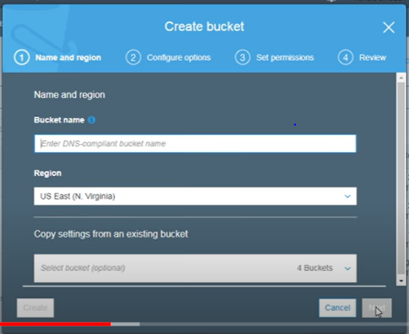

Open bucket-upload and add files

We need to create a data source: - creating dataset meaning providing information- that’s is meta data- attributes using and its info

We need one more tab and login

Click on machine learning

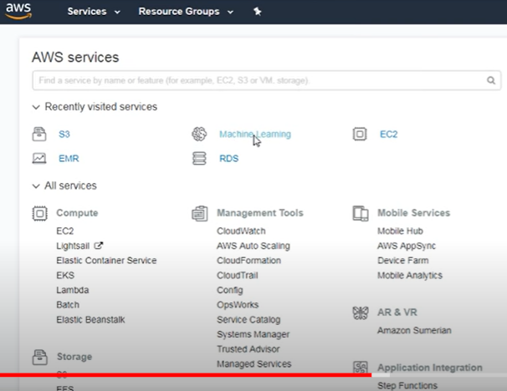

This page will open

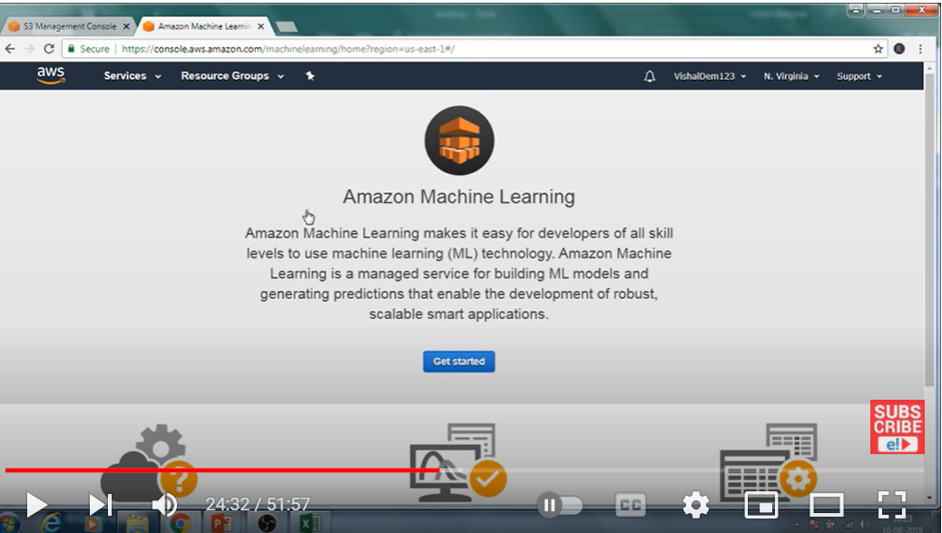

Now create metadata

Click on get started

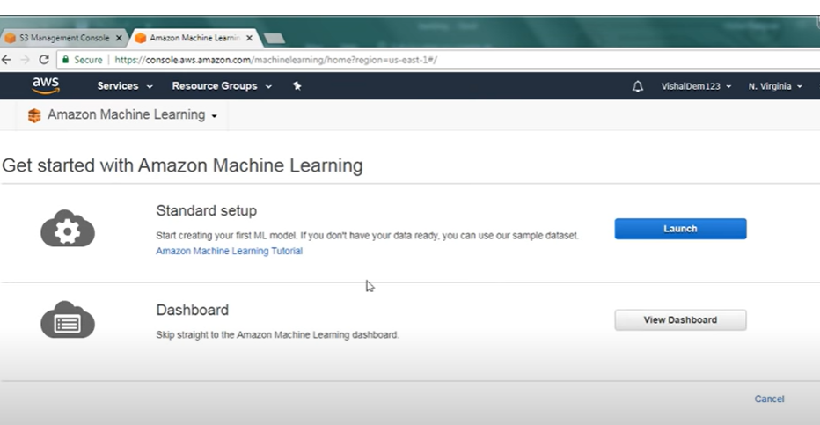

We have standard setup –

Go there-launch

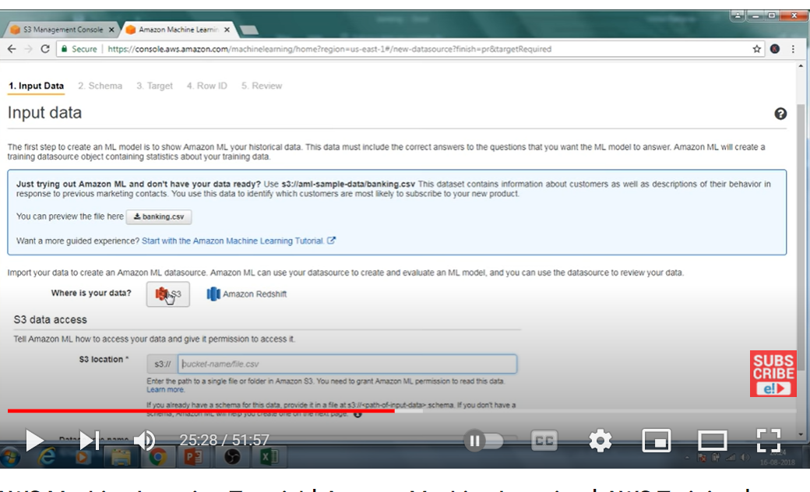

Upload details

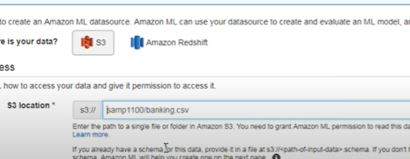bucket name and file name of s3

Once we fill data verify

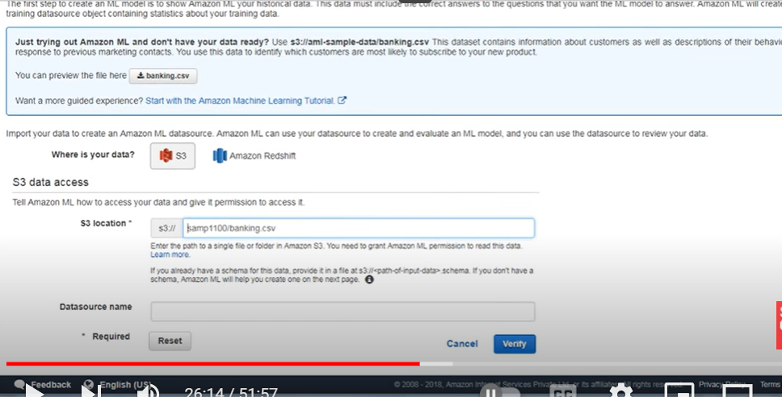

Then datasourse name comes automatically

Validation successful

This will come

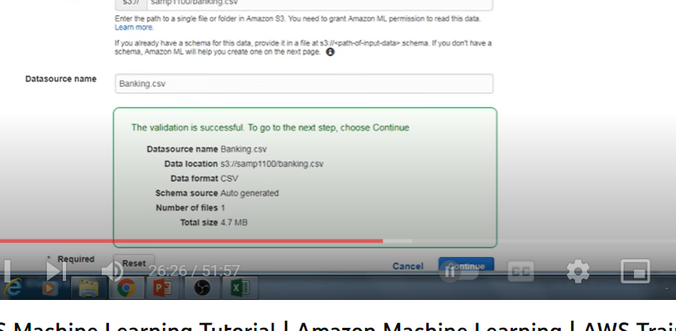

Click on continue

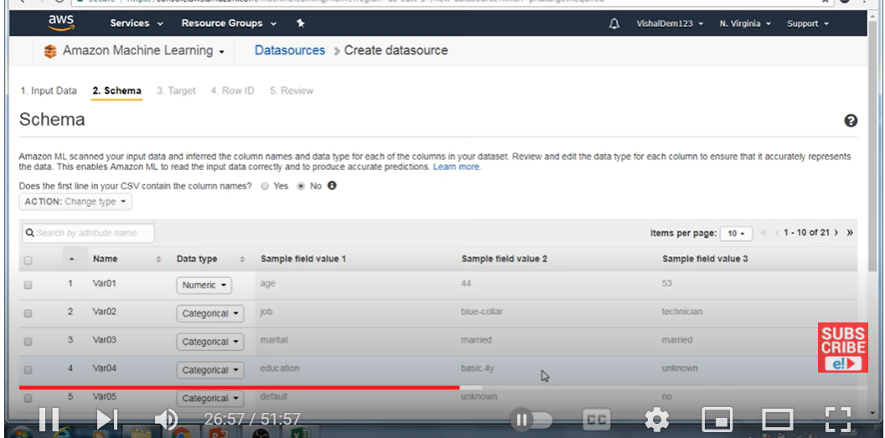

Column name and datatype we need to select,

If we see instead of column name some other names came

To modify that click above as yes

Now column names changed

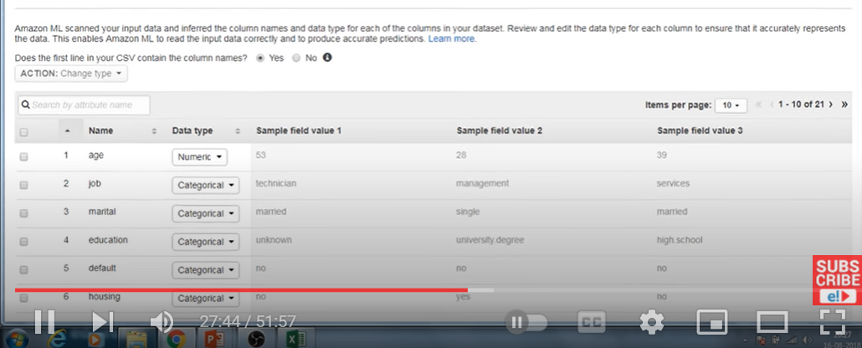

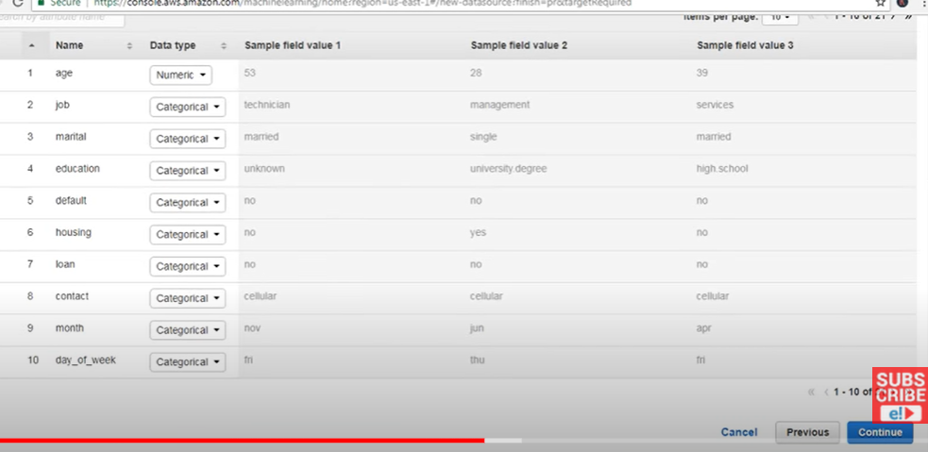

Continue

Now choose target variable

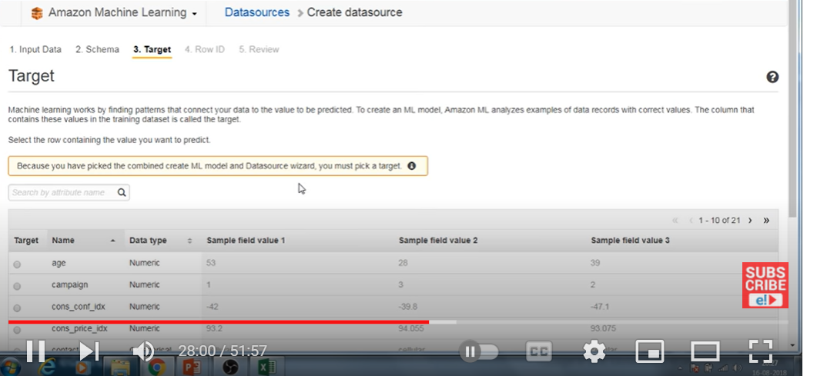

Continue

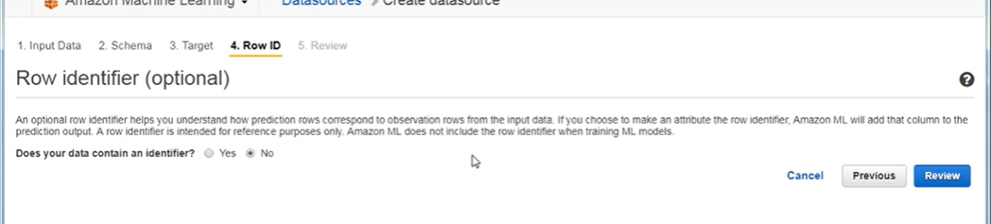

No for row identifier

Continue

-review

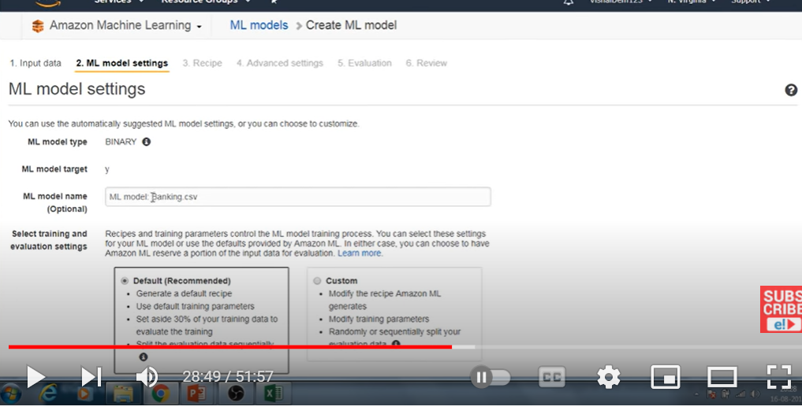

Now it will go ML model setting

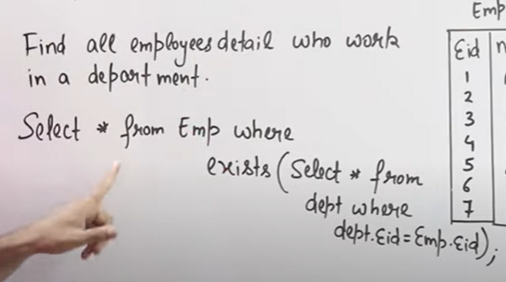

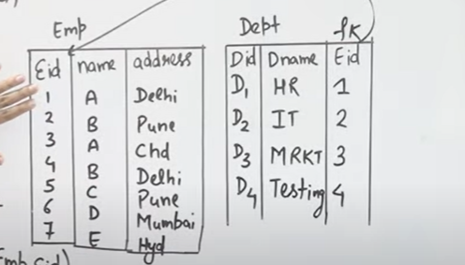

Exists connector which connect inner and outer query

Tru/false condition- it fetches data

One each record out outer query- all rows of inner query checks/run/compare with all lines of inner query

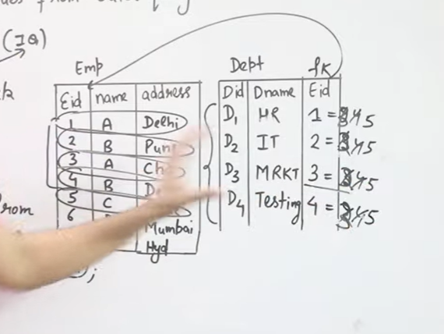

**Difference between Joins, Nested Subquery and Correlated Subquery | Most Imp Concept of SQL**

Nested query: query inside another query and another query

Bottom up

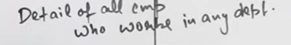

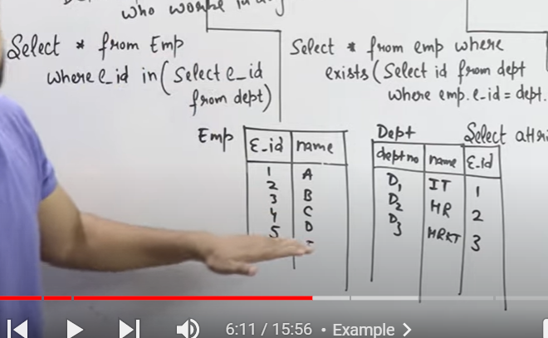

In nested query first inner query gets executed and its executes only one time

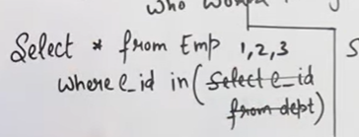

In means equal to

One person compare with another number(=)

One compare with group of num(IN)

**Correlated subquery :**

Top to down

Out side row execute first and

Inner query uses outside query

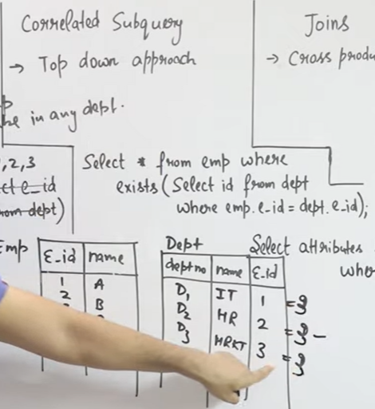

Each row of outer query compare every row in inner query

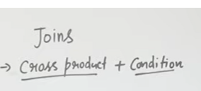

M*n number of rows

# Find Nth(1st,2nd,3rd....N) Highest Salary in SQL

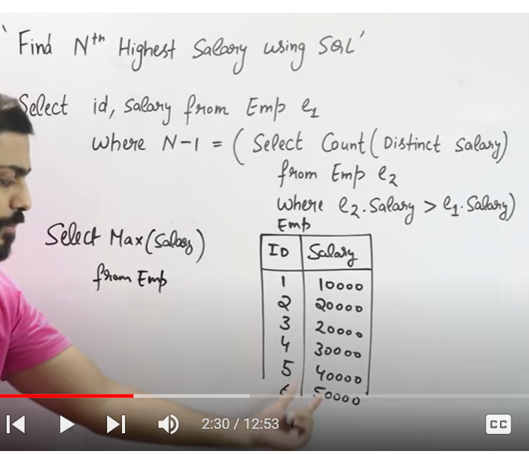

Max salary

2nd ighest

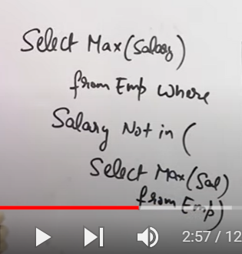

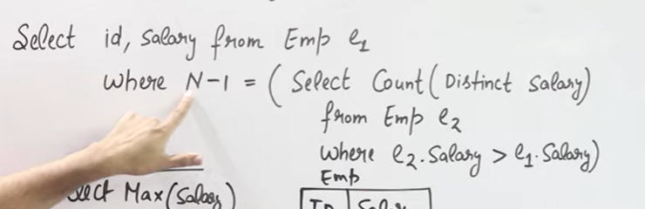

Its correlated sub query

Each line of outer query – compare all rows of inner query

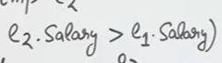

But 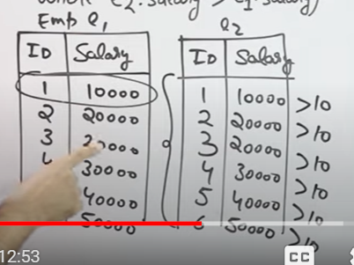

Inside values –count(distint salary ))

4 th highest

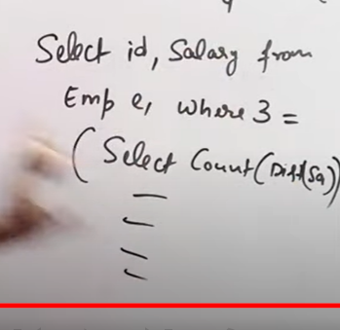

Compare 10000 first value

And checks condition with each value in second –



Note down number of times that condition came true –

9Compare that number with N-1

Checks till that condition becomes true



PL-SQL-Procedure sql, programming flavor- advanced sqll, what to do and how to do-declaring functions,procedure…declarative+procedural(what to do and how to do)

We want to cal a +b

Declae a,b, give value

And then we write function to add 2 numbers

Declare c=a+b

Function declare- c

Normal – sql- is declarative in nature- we will mention only what to do

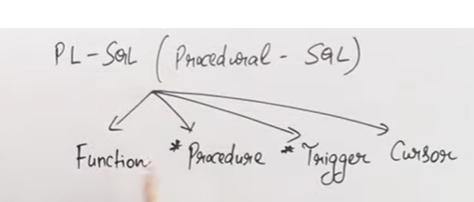

Write a pl-sql code- this is how they ask

Where as sql- write a query

Step: declaration of variables and data types

2 step: executable

Starts with begin and end with end

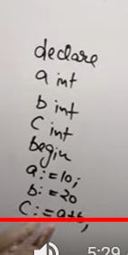

We use

C:=

Since normal = will be used to compare

Step3: exceptional handling

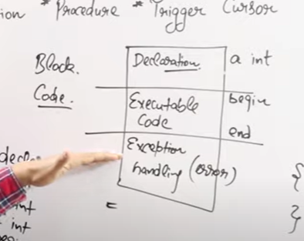

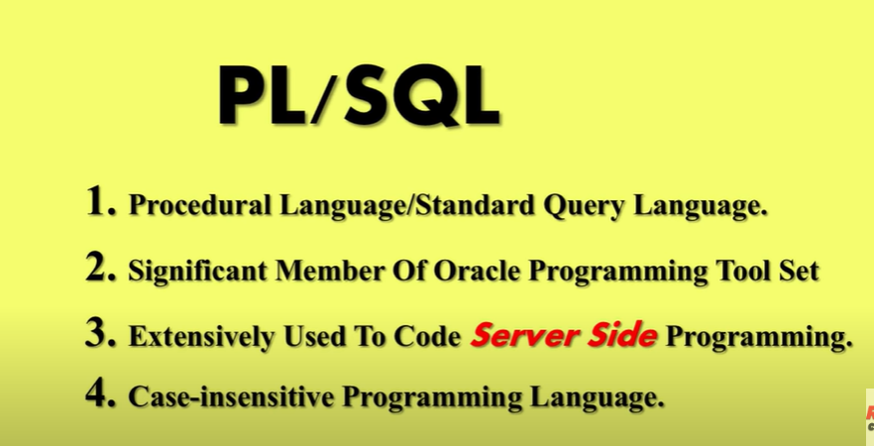

Blocks: code devided into blocks

Blocks are basic unit of plsql

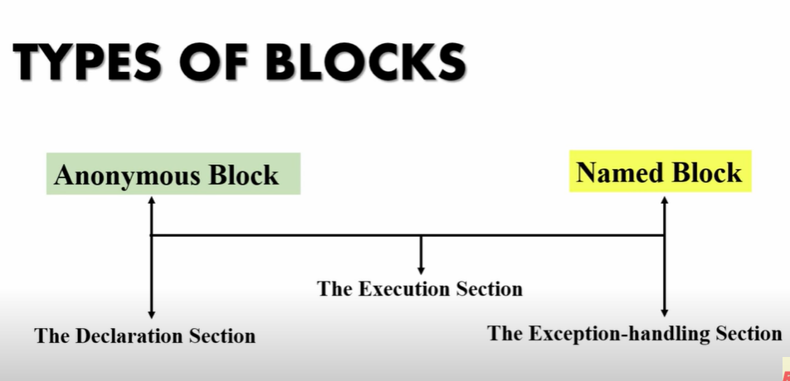

Execution sec: mandatory

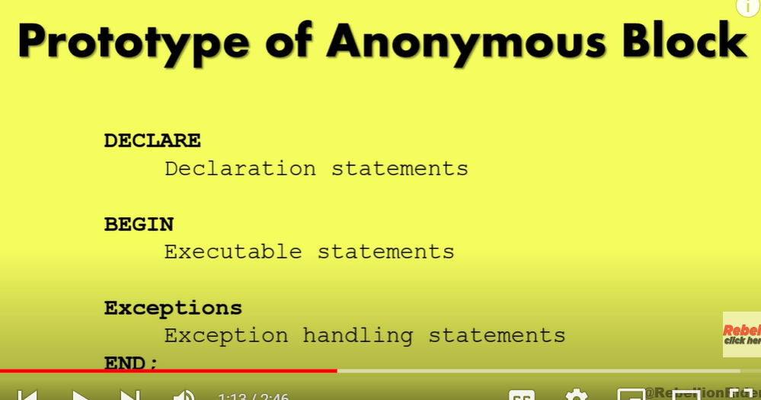

Declaration section:

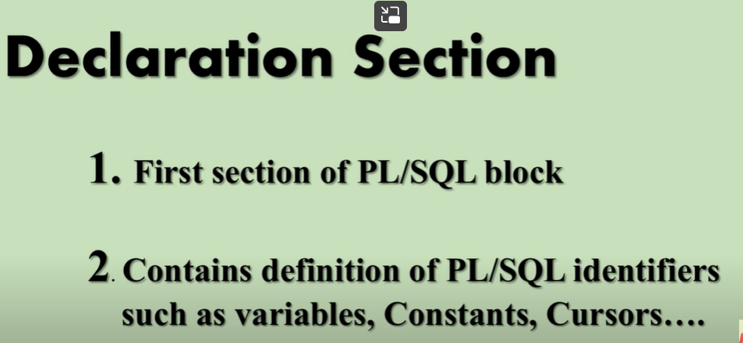

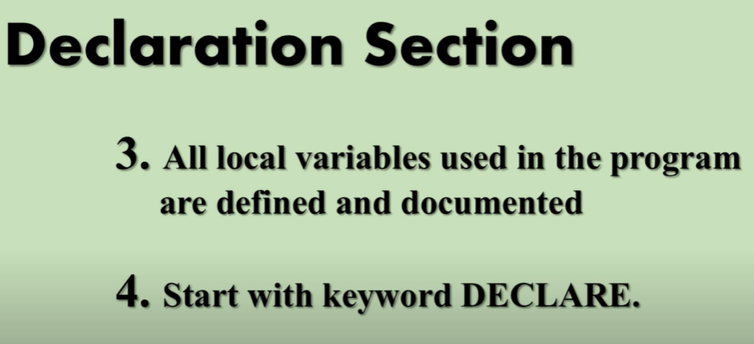

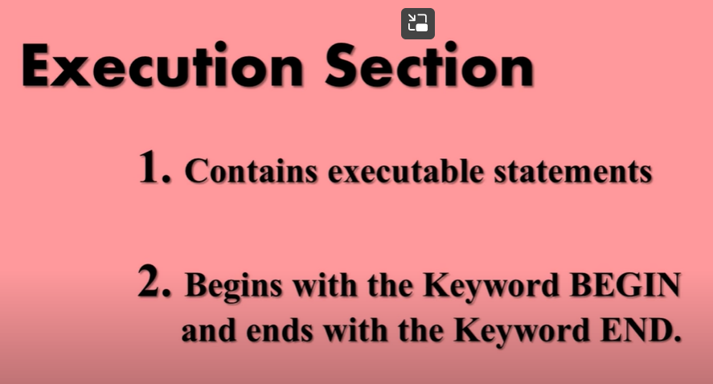

Mandatory

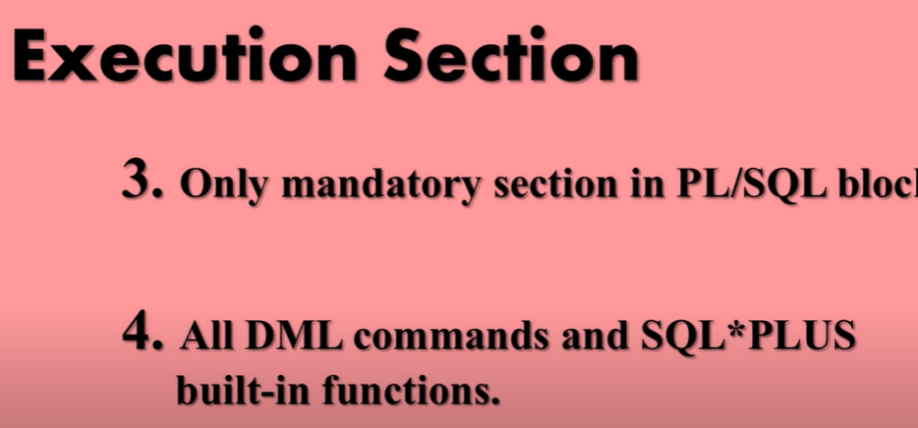

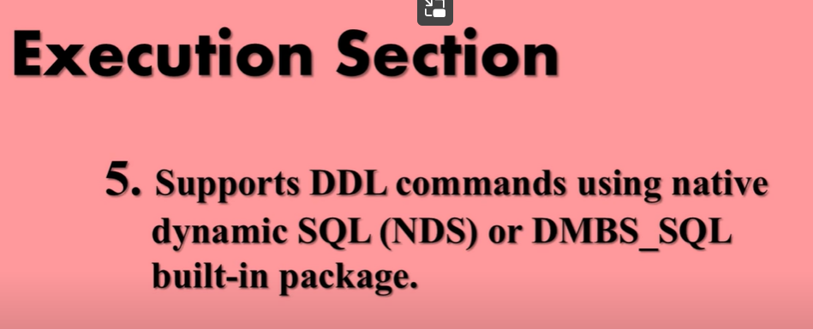

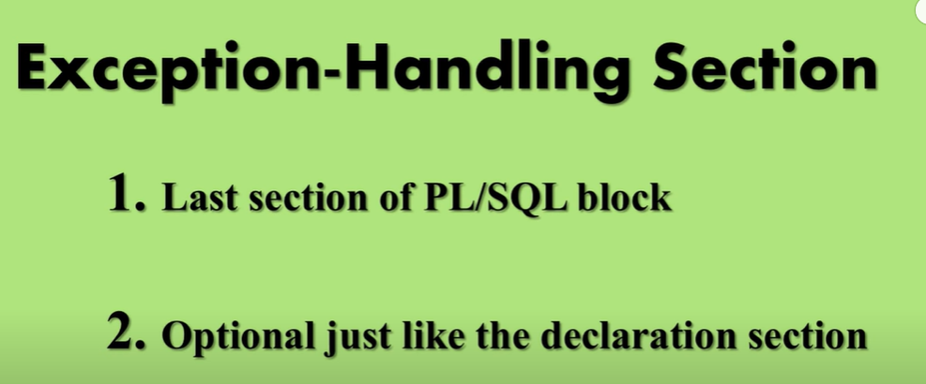

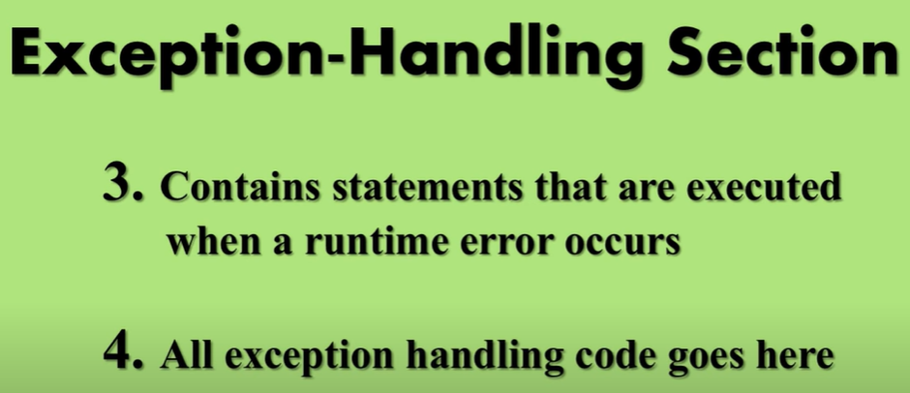

# PL/SQL Variables in Oracle Database

Diff ways to declare variables

Variables are place holder that can hold variables in computer data

Can be changed – variable in nature can be changes at any place in progamme

Variable must be declare with

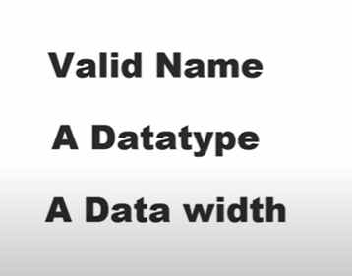

And variables must be declare at beginning

In declare section

Set sqrver output on: allow server to communicate and shows display of result

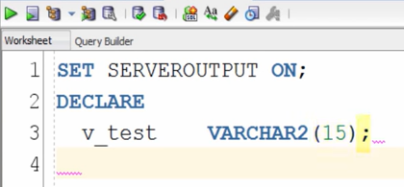

**Intialization:**

After declare we need to initialize, assign value to variable

Initialization can be done in any where of programe

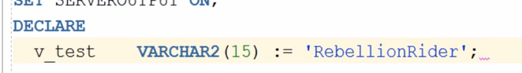

:= is assignment operator in pl sql

After declaration: use ;

In execute sec initialization must be done in

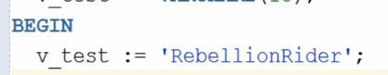

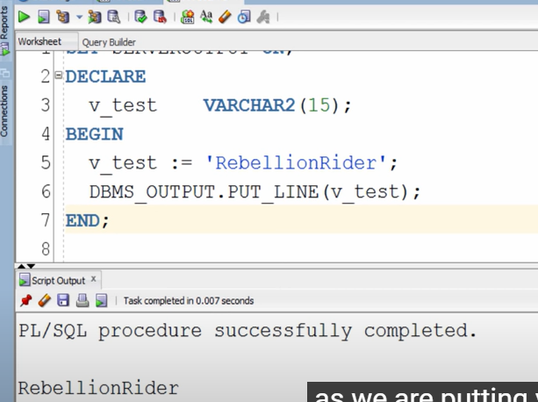

After execution result will come at the end

# SELECT INTO statement in PL/SQL

How to initialize variables in select into statement

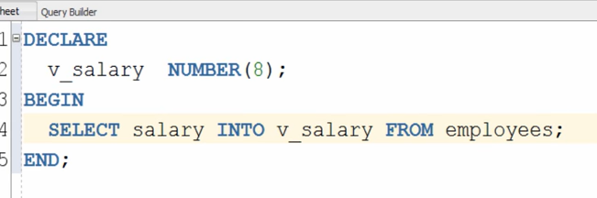

Select column into variable_name

Above execution will fail as salary has multiple records where as we need single record

So we must use condition to get single record

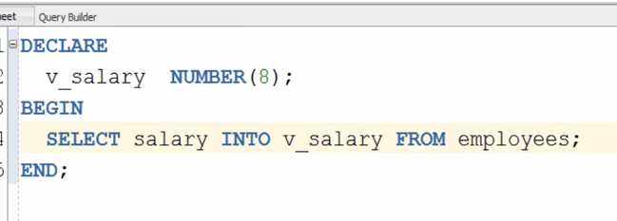

We can also solve this proble by using “collection”

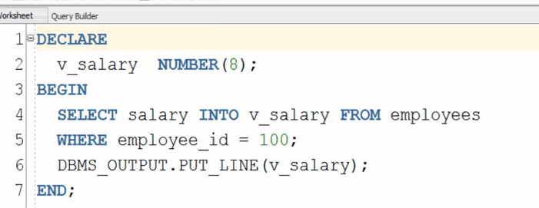

Put_line(v_salary)- to display result

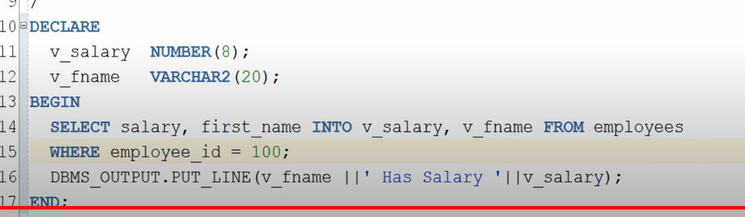

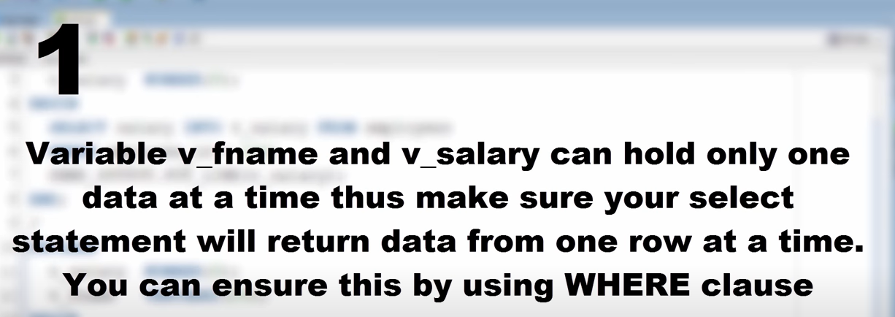

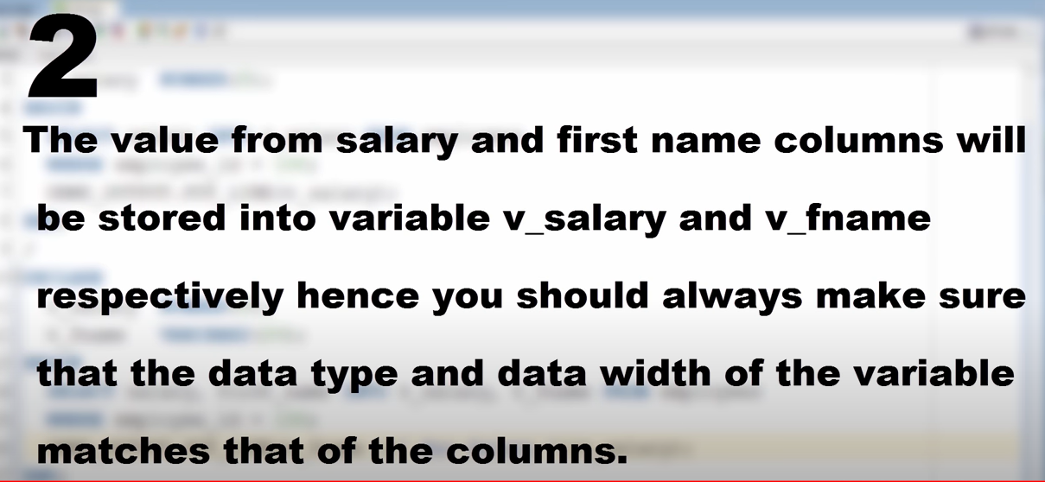

# Anchored Datatype (%TYPE) in PL/SQL

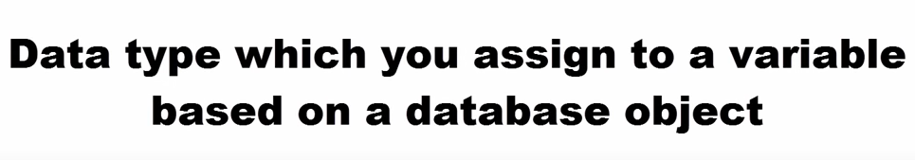

Unlike variables data type it is not dependent on underlying object

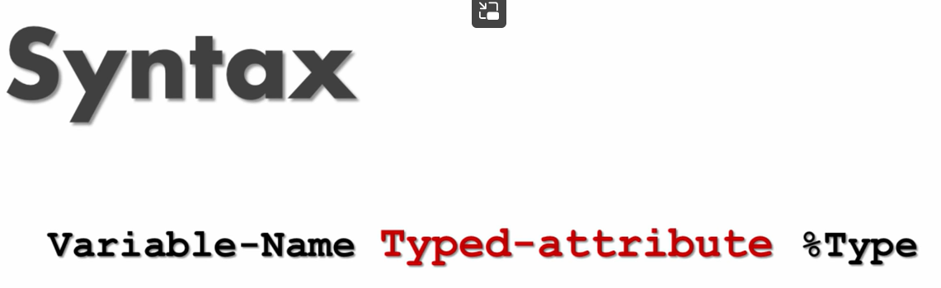

Actual table

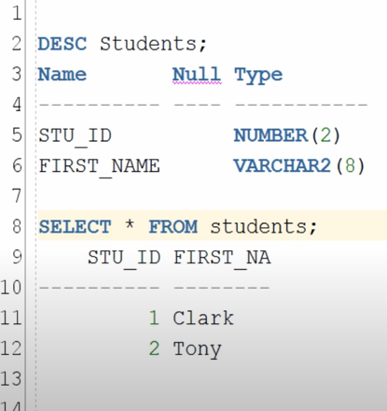

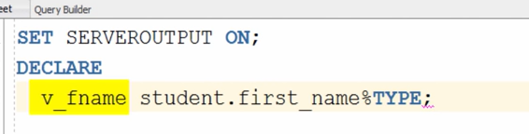

Here we declare name of variable(v_fname)

And from table the column which it referes to: student.first_column

%TYPE(it takes data type of tht variable)

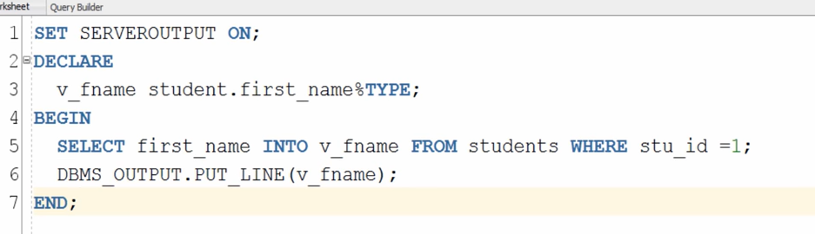

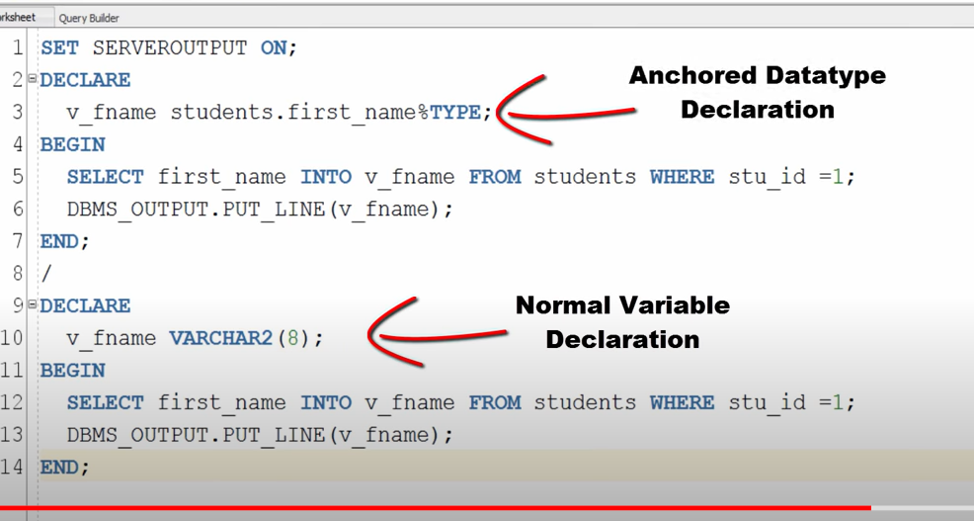

Below normal variable declaration: will have some proble

1. We must know data type of variable to declare
2. In future if someone changes data type of base table- code execution will fail
3. So better use anchored data type

# PL/SQL Constants in Oracle Database

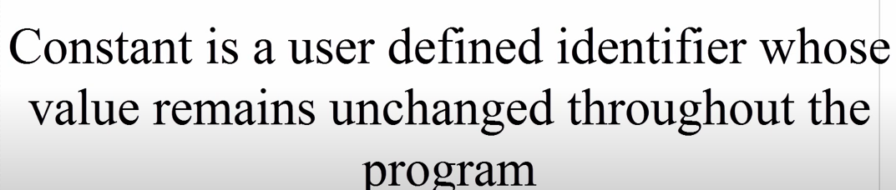

Like variable constants should dec;are prior to its use and in declare block

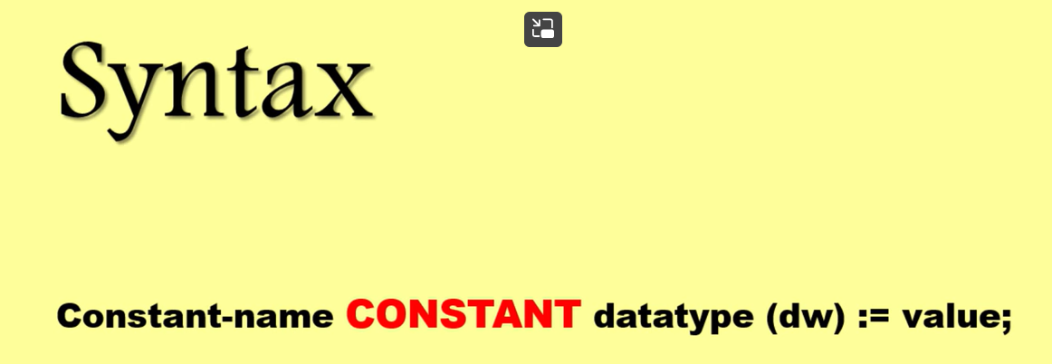



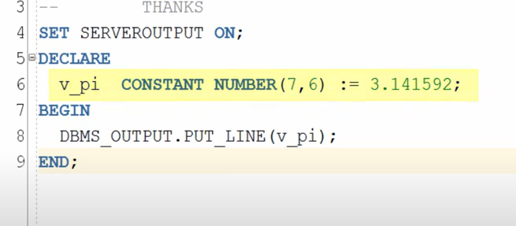

We will get an error if we initialize constant in exc sec

This will not be acceptable by compiler

2 more attribute for to intialiaze constants: Default and not null

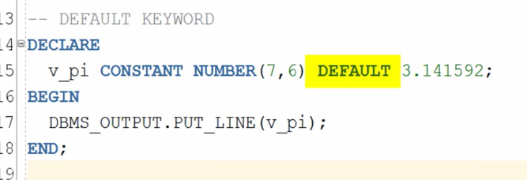

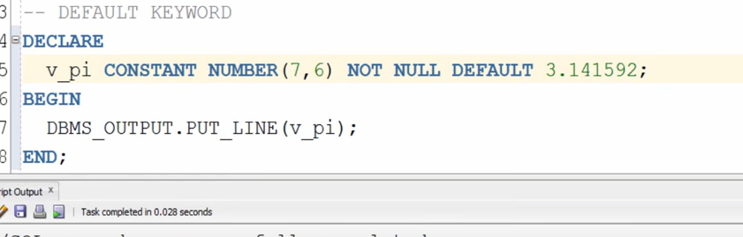

# Bind Variable in PL/SQL

2 types of variable

User variable

2. bind variable or host variables: can declare any where

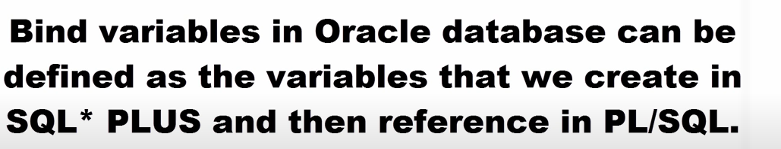

For declare we don’t req block

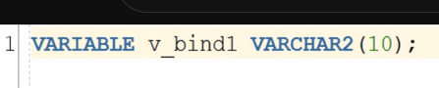

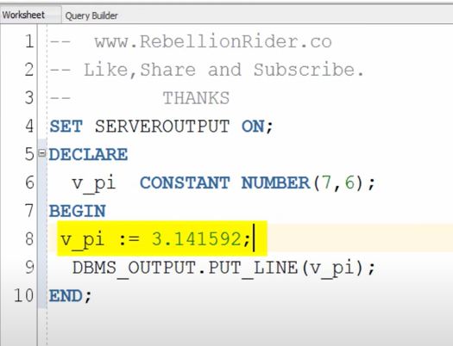

# Bind Variable in PL/SQL

Host variable

* We can declare any where in any where in host env
* 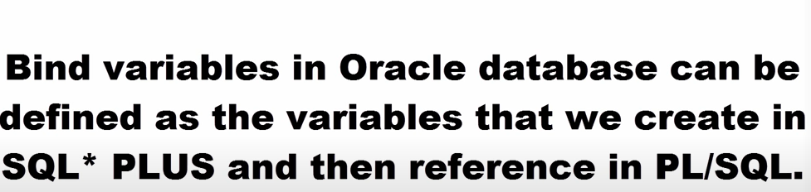
* Declare blind variable by using variale
* No need block
* 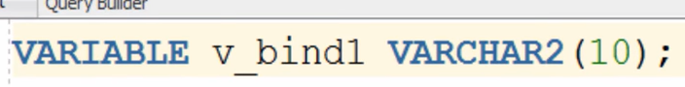
* Initialize blind variable:
* By using execute command

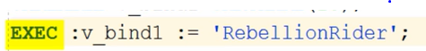

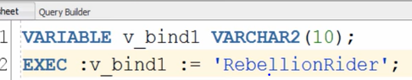

Another way of initializing explicitly wring in exec sec

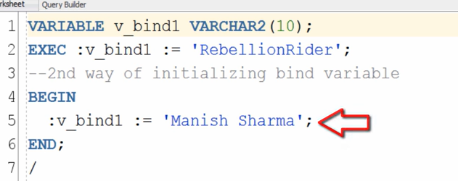

: before name

How to display values of blind variable?

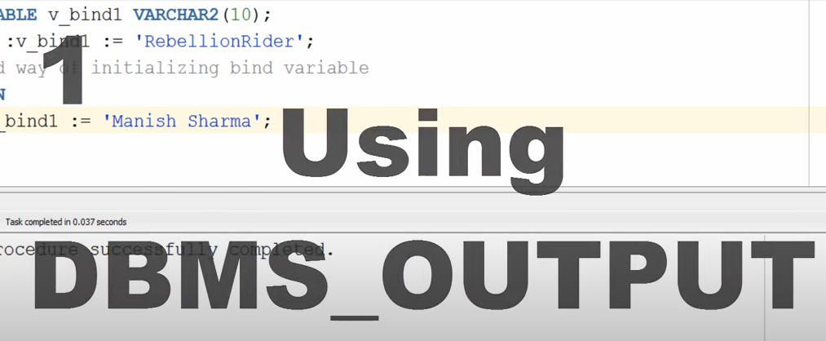

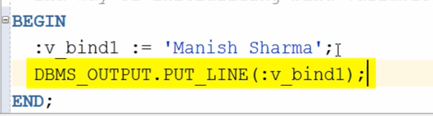

We can use only in exec sec

2nd way – using print command – any where in host envt, not require any block

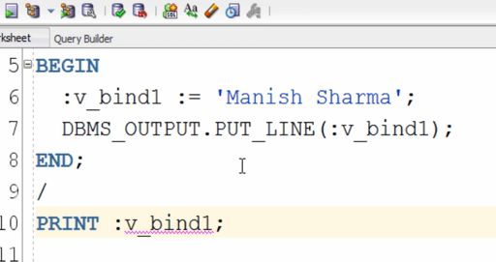

At the end we need to write this command

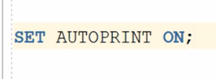

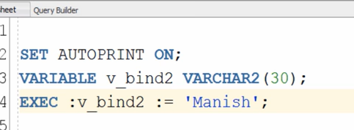

# Introduction to PL/SQL Conditional Statements in Oracle

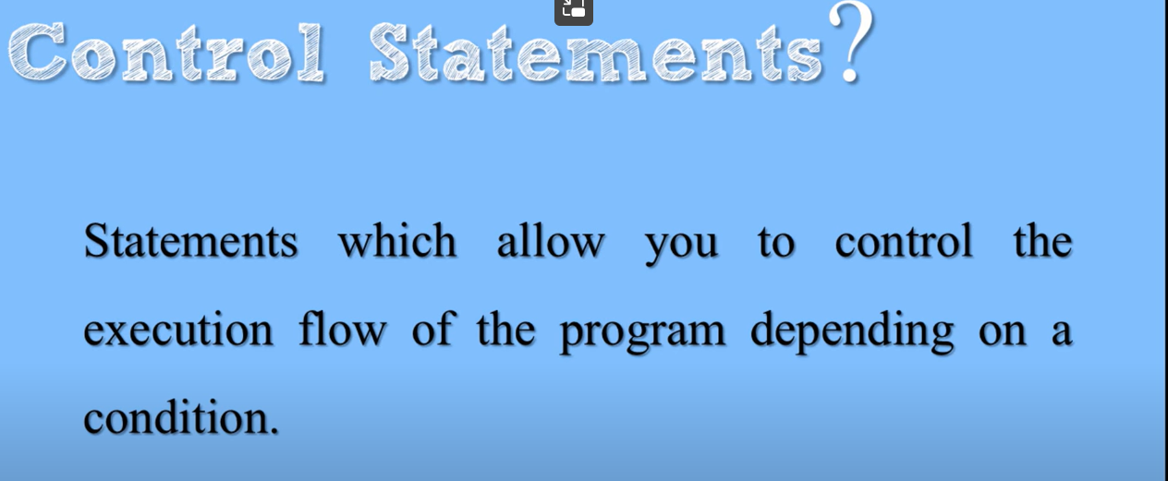

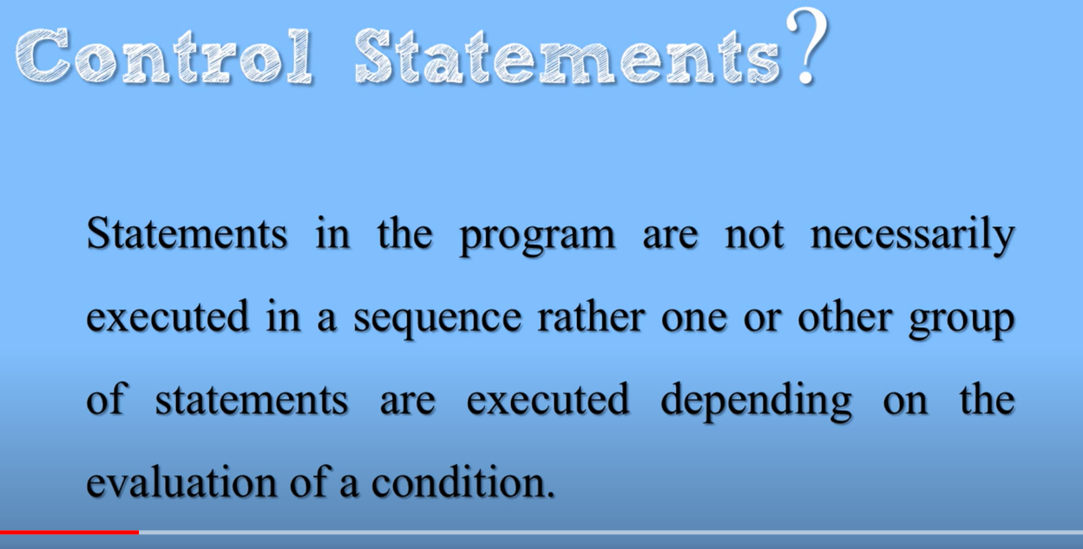

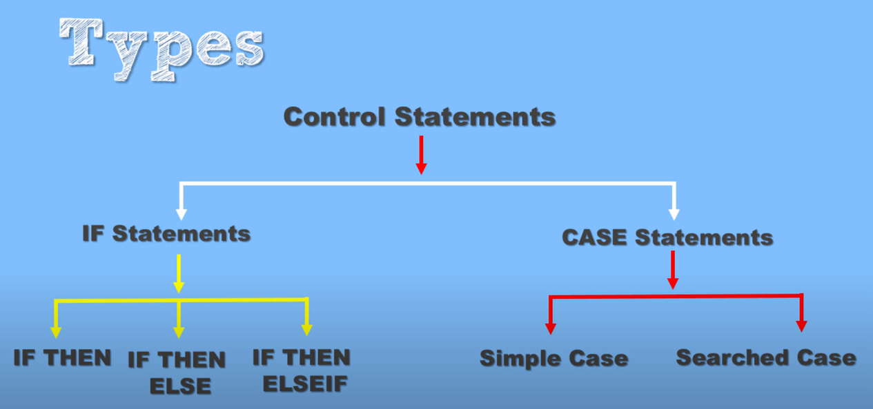

# Simple Case Expression

Case expressions Can be used decode expression

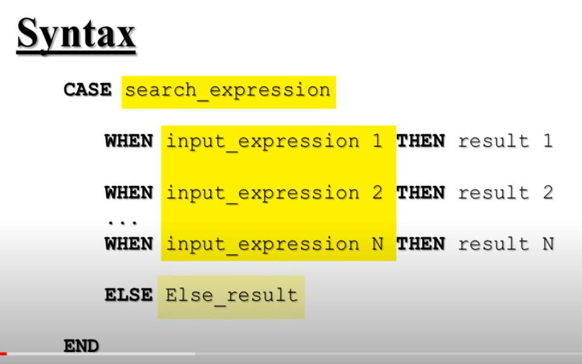

Else is optional

If don’t mention null will be displayed

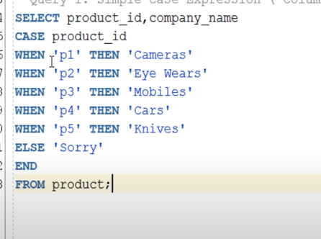

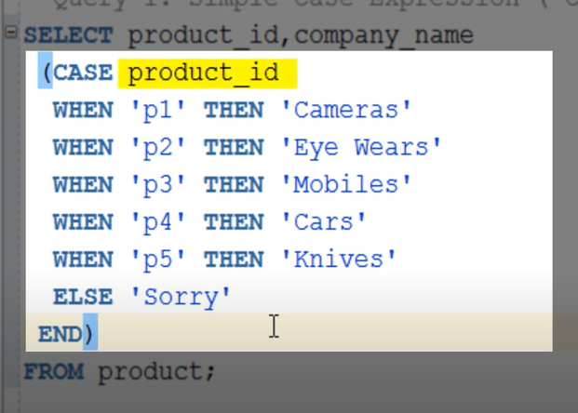

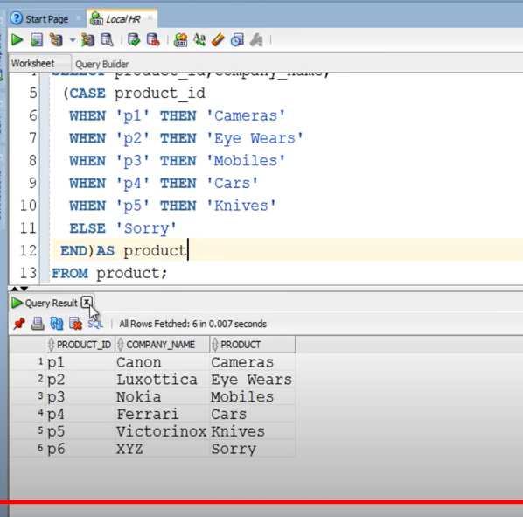

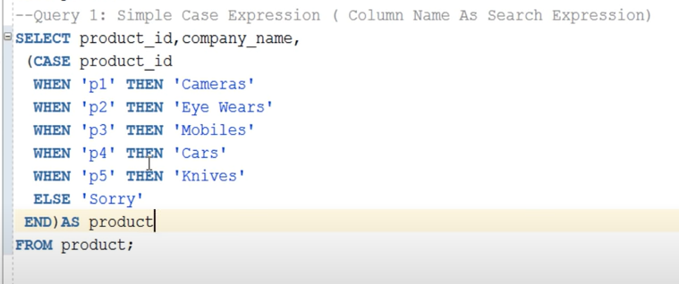

Simple case: column name as search expression

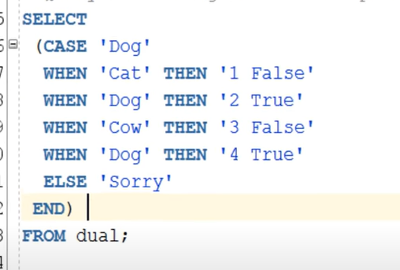

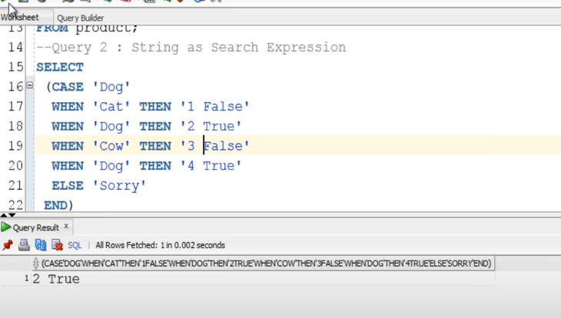

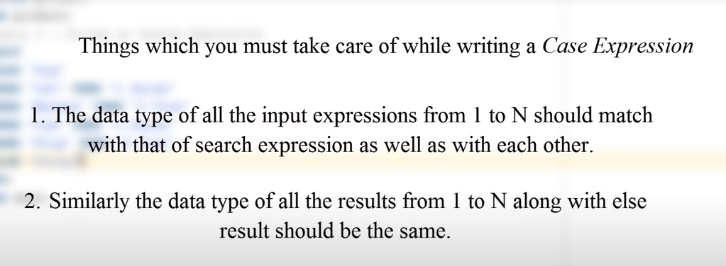

# CASE - Searched Case Expression

One level higher than searched case expression

We will not have any search expression after case word

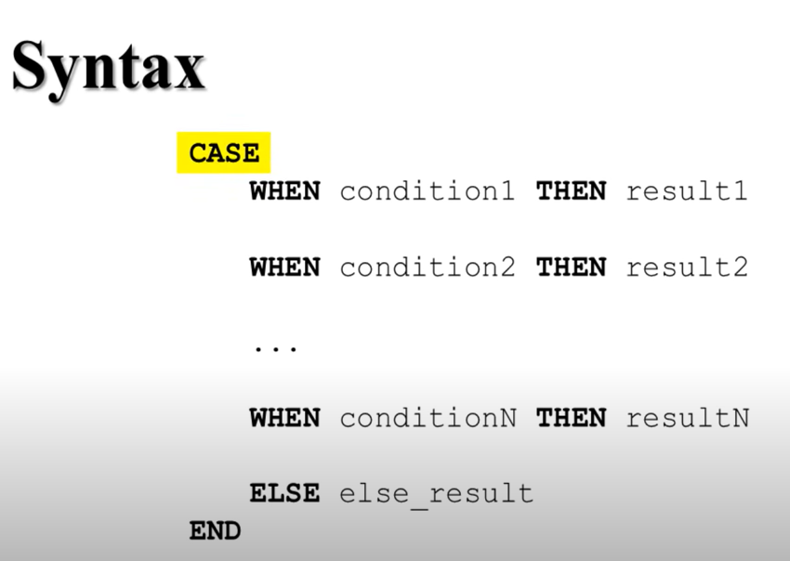

Here we will have conditions rather than search expression

We can use comparison or logical operator

Condition true- returns value

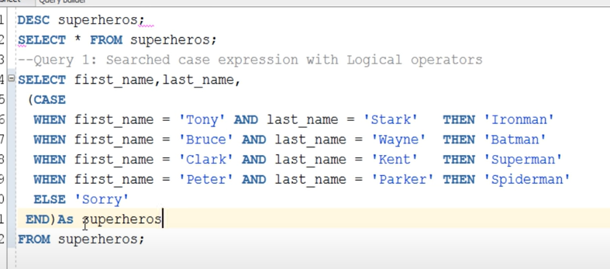

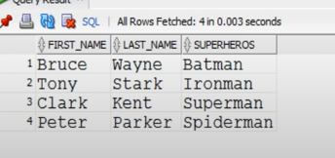

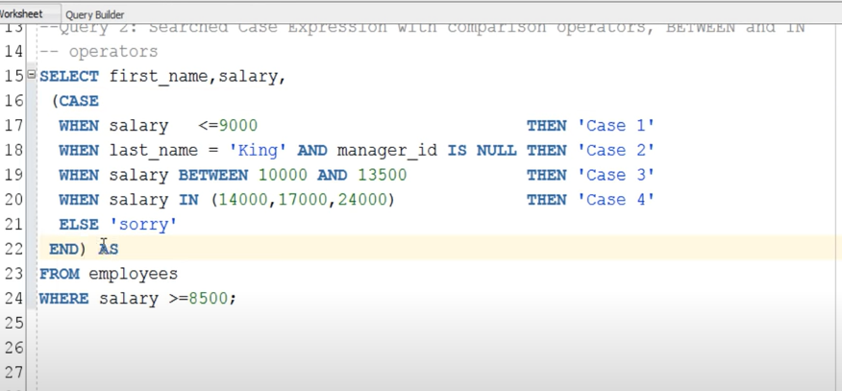

# Simple IF -THEN conditional Control Statement

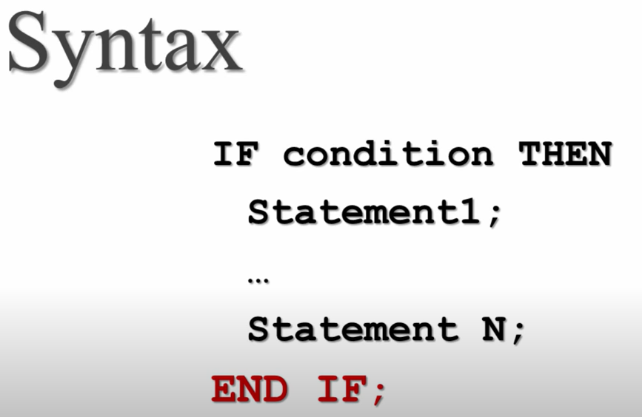

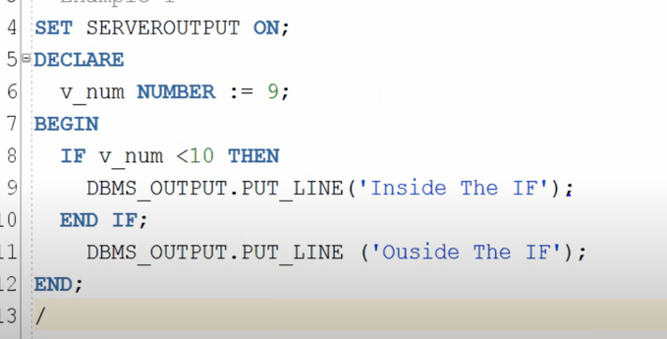

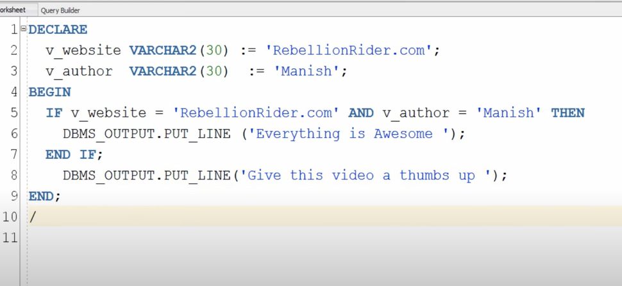

If : print works only if condition is true

Below print- will print (compulsory)

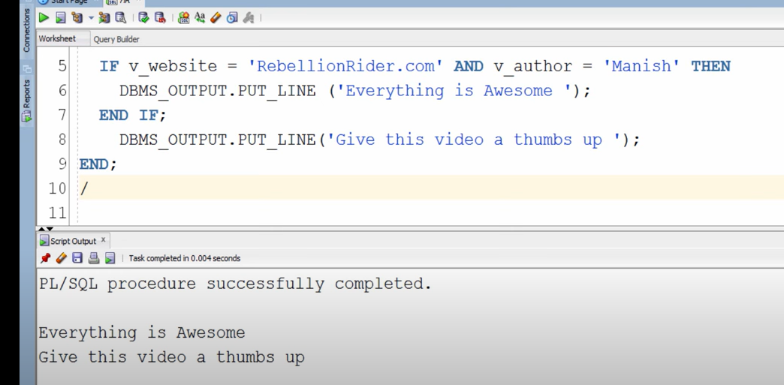

# : IF THEN ELSE (IF-ELSE) Statement in PL/SQL

Drawback -if then

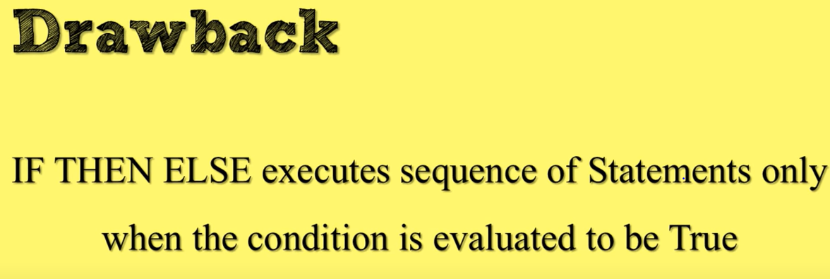

In case false – no action is proceed to take

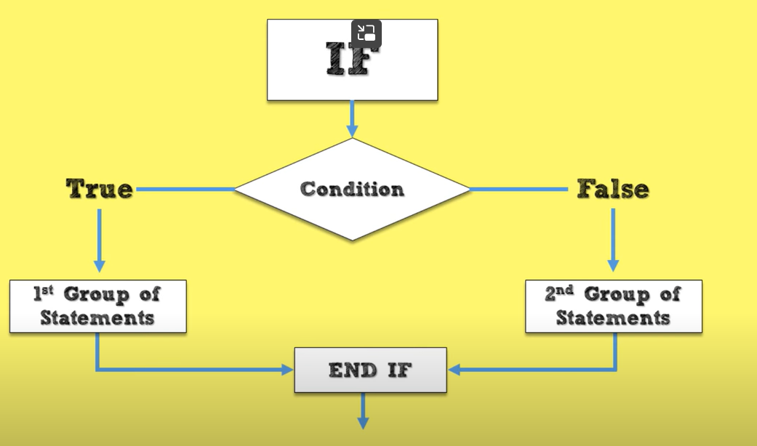

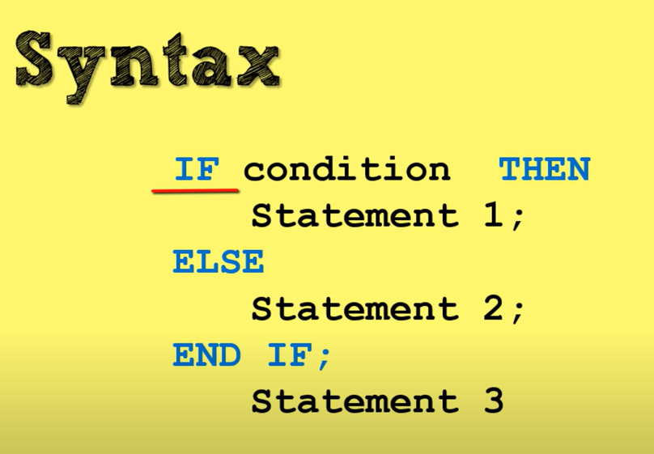

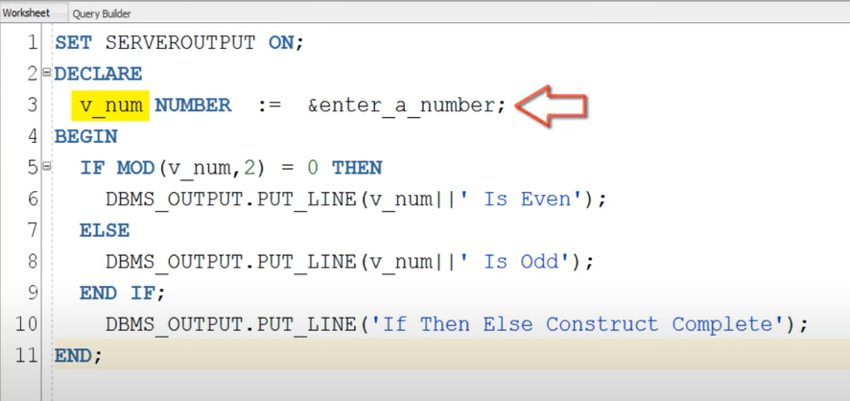

# PL/SQL IF THEN ELSIF Statement

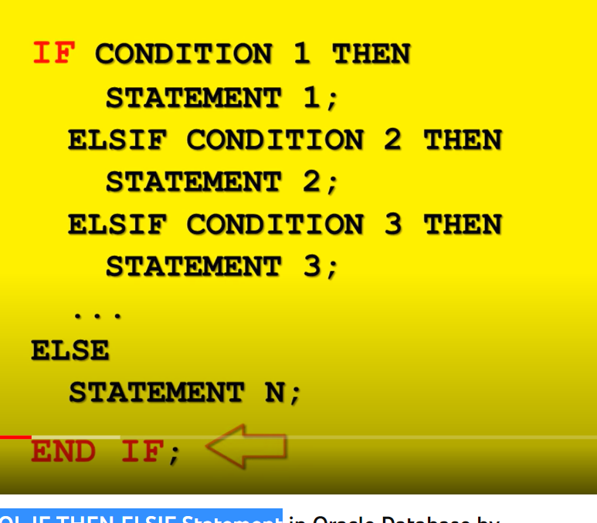

Multiple conditions

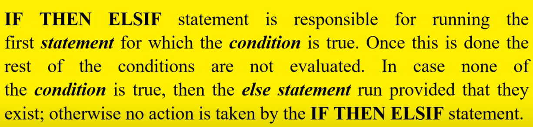

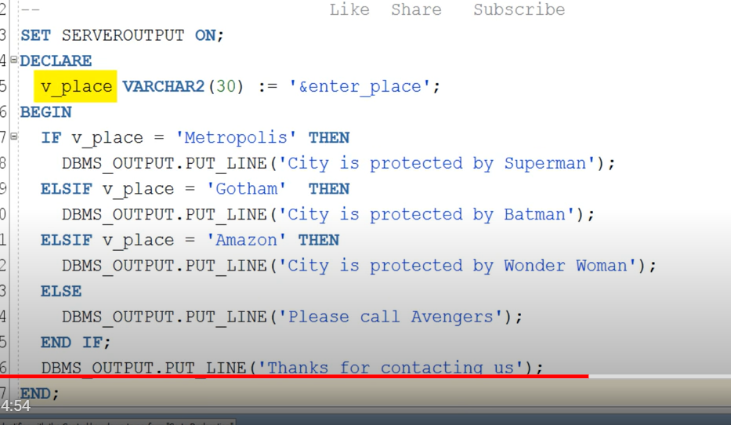

# PL/SQL Simple Loop in Oracle Database

Most basic loop

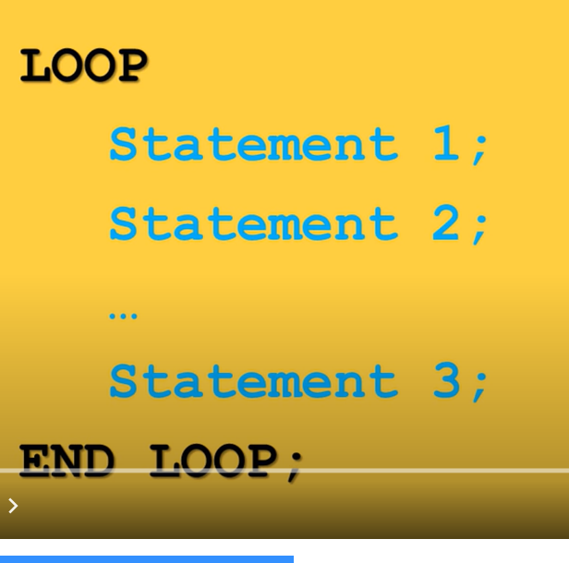

We don’t have updated conditions

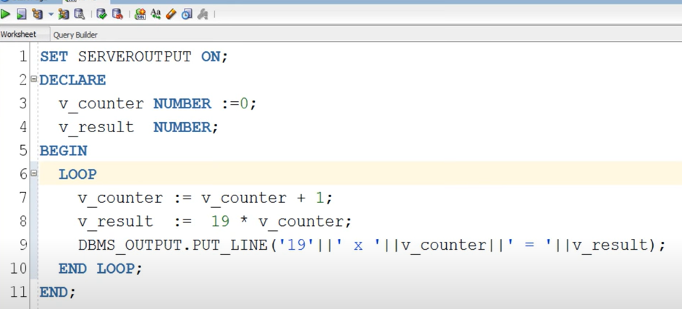

In this look there is no statement which controls the loop

Loop continue to execute

Oracle – give 2 clauses to end loop:

1. Exit
2. Exit when
3. Exit – execute when exit condition is true – using if
4. 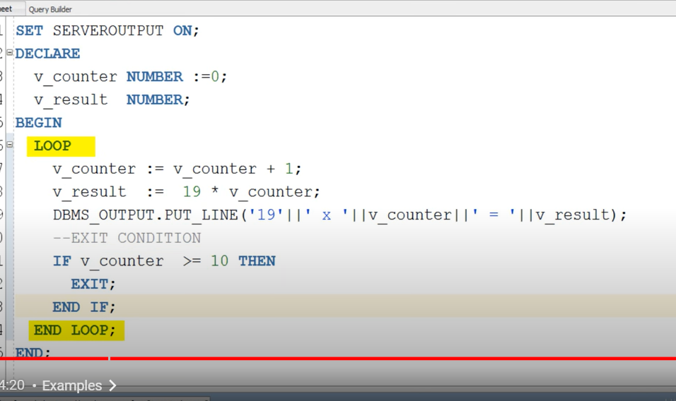

If – when replace if then condition of above loop

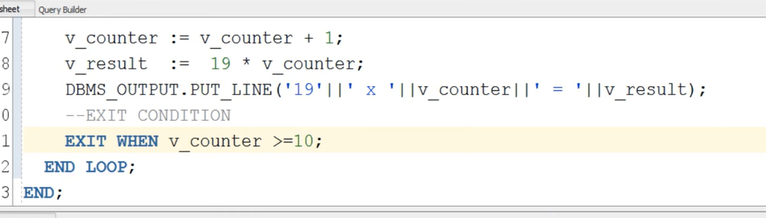

# PL/SQL WHILE Loop in Oracle Database

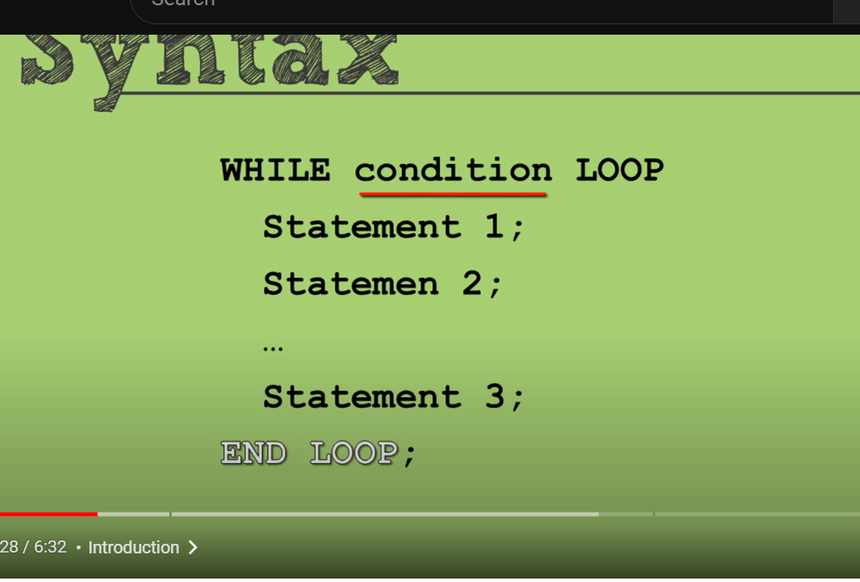

Usable when number of loops performed to be unknown

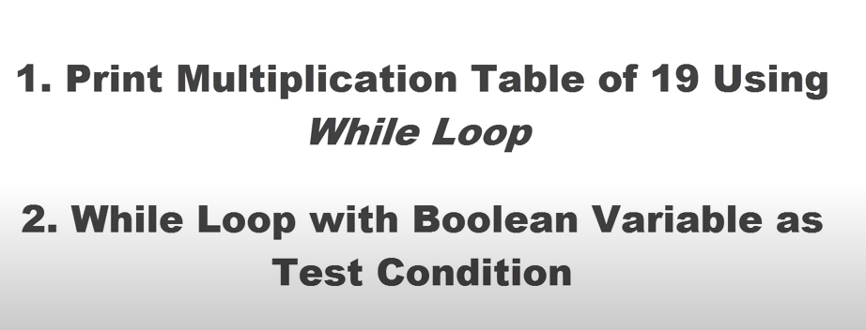

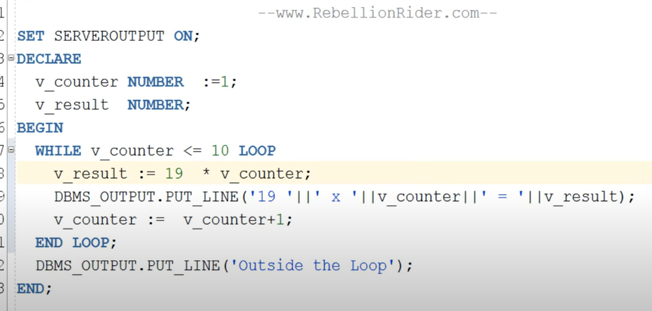

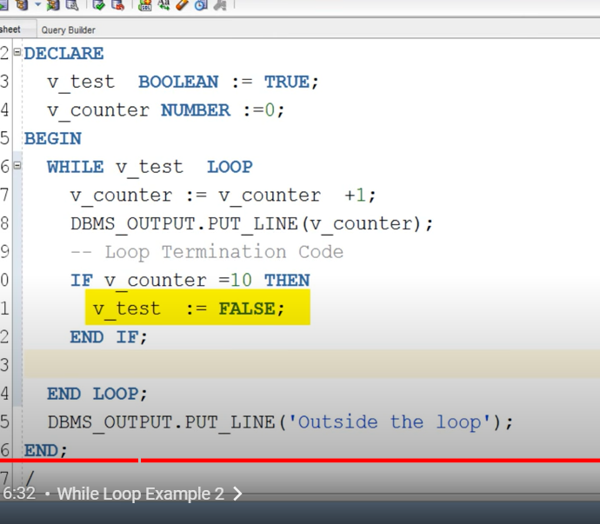

# PL/SQL FOR Loop In Oracle Database

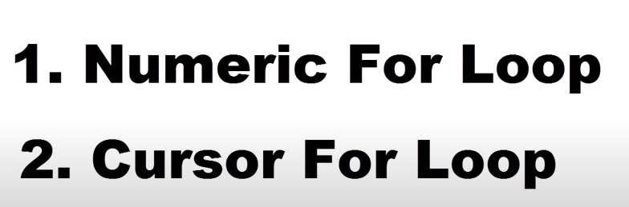

Cursor for loop will be explained during cursors



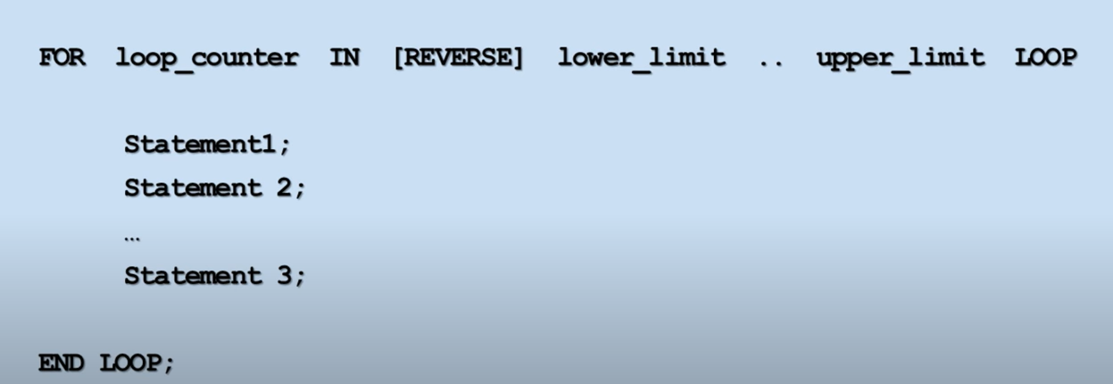

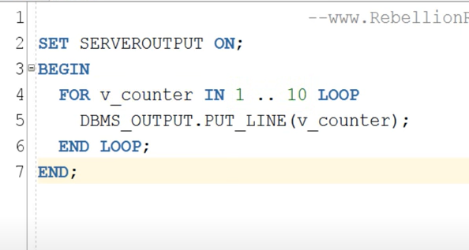

For reverse

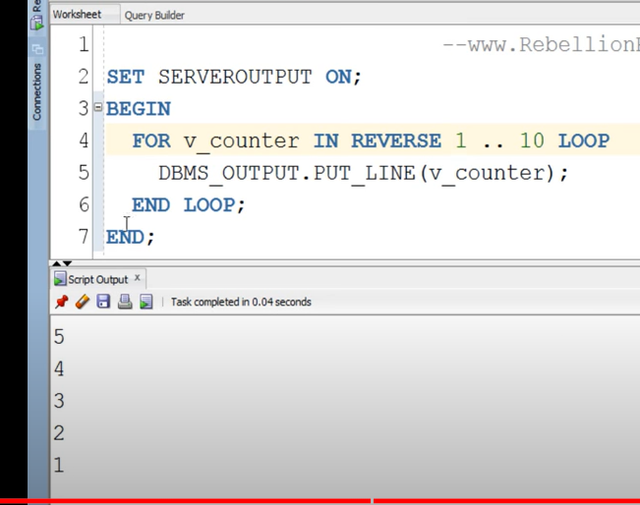

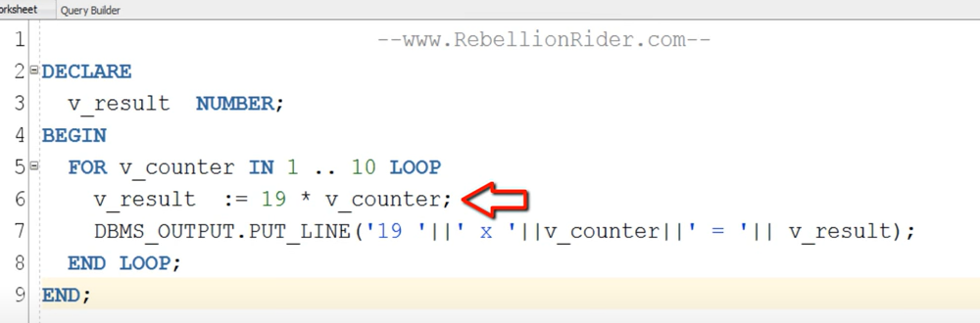

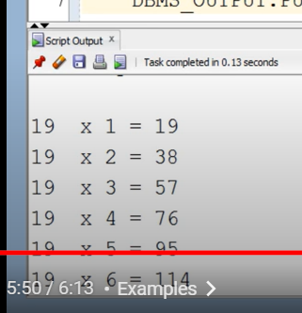

[PL/SQL tutorial 13: PL/SQL FOR Loop In Oracle Database by Manish Sharma RebellionRider.com - YouTube](https://www.youtube.com/watch?v=DfAmnj2j7WI&list=PLL_LQvNX4xKyiExzq9GKwORoH6nvaRnOQ&index=13)

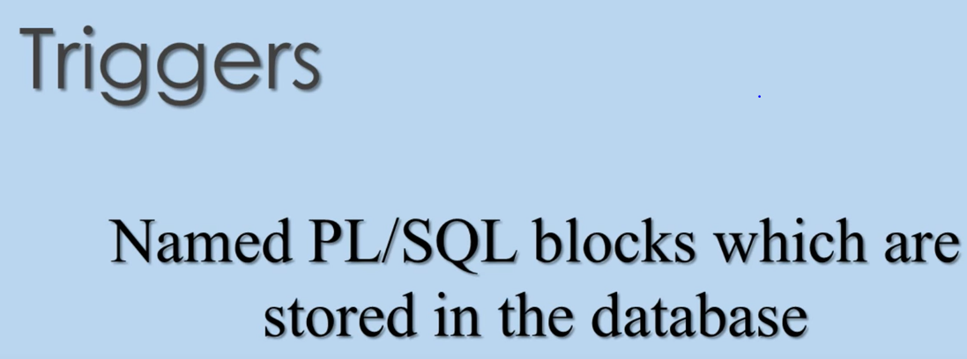

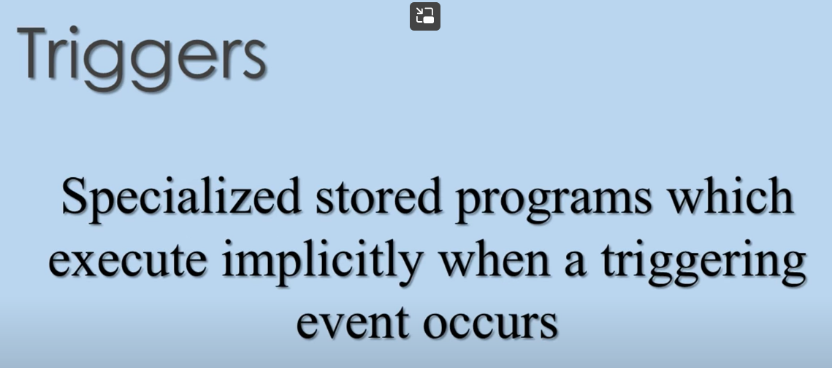

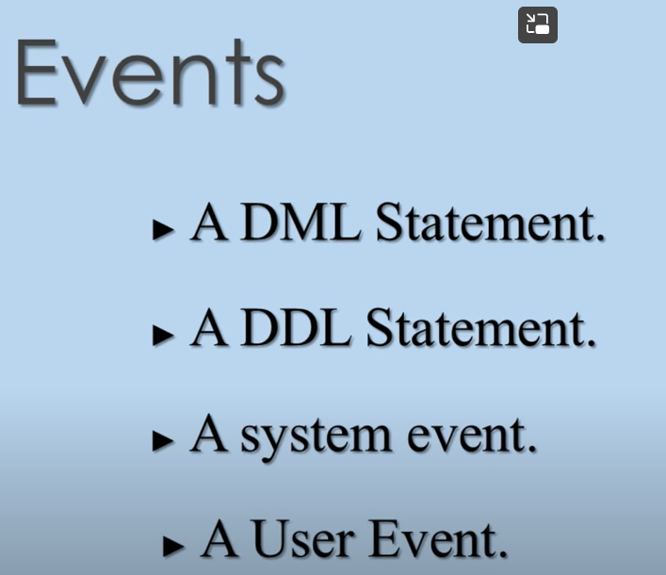

Update,isnull,delte

System event: shut down and start of dbms

User event: login logoff

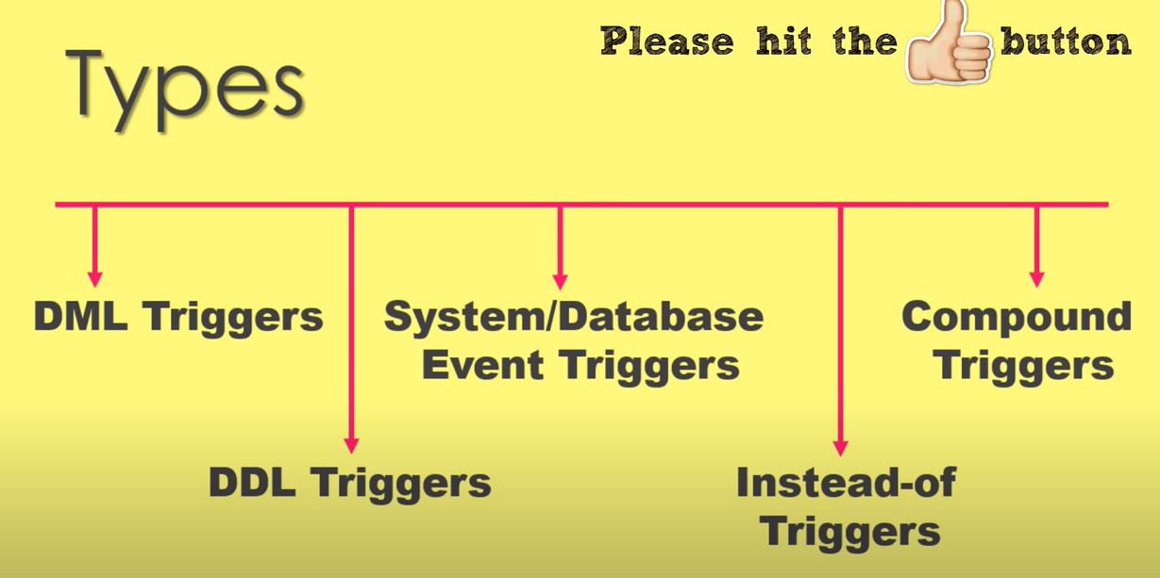

Instead of: stop, redirect performance of dml statement, way to manage updatable views

Compound: multi tasking trigger

Row level

Check

Save and replace

Triggers are named **PL/SQL blocks** which are stored in the database.

We can also say that they are **specialized stored programs** which execute **implicitly when a triggering event occurs**.

This means **we cannot call and execute them directly instead** they only get triggered by events in the database.

### **Events Which Fires the Database Triggers**

These events can be anything such as

1. **A DML Statement**– An **Update, Insert or Delete statement** executing on any table of your database.

You can **program your trigger to execute either BEFORE or AFTER executing your DML statement**.

For example, you can create a **trigger which will get fired Before the Update.** Similarly, you can create a trigger which will get triggered after the execution of your INSERT DML statement.

1. **A DDL Statement** – Next type of triggering statement can be a DDL Statement such as CREATE or ALTER. These triggers can also be executed either BEFORE or AFTER the execution of your DDL statement. These triggers are generally used by **DBAs for auditing purposes**. **And they really come in handy when you want to keep an eye on the various changes on your schema**. For instance, who created the object or which user. Just like some **cool spy tricks.**
2. **A system event**. – Yes, you can **create a trigger on a system event**. And by a system event, I mean **shut down or startup of your database.**
3. **A User Events** – Another type of triggering event can be **User Events such as log off or log on onto your database**. You can create a trigger which will either execute before or after the event. Furthermore, **it will record the information such as time of event occur, the username who created it.**

## **Types of Database Triggers**

There are 5 types of triggers in the Oracle database. **3 of them are based on the triggering event** which are discussed in the previous section.

#### **Data Manipulation Language Triggers or DML triggers**

As the name suggests these are the triggers which **depend on DML statements such as Update, Insert or Delete.** They get fired either before or after them. Using DML trigger you can **control the behavior of your DML statements**.

You can a**udit, check, replace or save values before they are changed.**

**Automatic Increment of your Numeric primary key is one of the most frequent tasks of these types of triggers.**

#### **Data Definition Language Triggers or DDL triggers.**

Again as the name suggests these are the type of triggers which are created over DDL statements such as **CREATE or ALTER**. They get fired either before or after the execution of your DDL statements. Using this type of trigger you can **monitor the behavior and force rules on your DDL statements**.

#### **System or Database Event triggers.**

Third type of triggers is system or database triggers. These are the type of triggers which come into action when some system event occurs such as **database log on or log off.**

You can use these triggers for **auditing purposes**. For example, keeping an eye on information of system access like say **who connects with your database and when.** Most of the time System or Database Event triggers work as **Swiss Knife for DBAs** and help them in **increasing the security** of the data.

#### **Instead-of Trigger**

This is a type of trigger which **enables you to stop and redirect the performance of a DML statement**.

Often this type of trigger **helps you in managing the way you write to non-updatable views.** You can also see the application of business rules by INSTEAD OF triggers where they **insert, update or delete rows directly in tables that are defining updatable views.**

Alternatively, sometimes the INSTEAD OF triggers are **also seen inserting, updating or deleting rows in designated tables** that are otherwise unrelated to the view.

#### **Compound triggers**

These are multi-tasking triggers that **act as both statement as well as row-level triggers** when the data **is inserted, updated or deleted from a table**. You can capture information at **four timing points** using this trigger:

* before the firing statement;
* prior to the change of **each row** from the firing statement;
* **post each row** changes from the firing statement;
* after the firing statement.

All these types of triggers can be used to audit, check, save and replace the values. Even before they are changed right when there is a need to take action at the statement as well as at row event levels

## **Uses of Database triggers.**

1. Using database triggers **we can enforce business rules** that **can’t be defined by using integrity constants.**
2. Using **triggers we can gain strong control over the security**.
3. We can also **collect statistical information on the table access**.
4. We can automatically **generate values for derived columns such as auto increment numeric primary key.**
5. Using **database triggers we can prevent the invalid transactions.**

[bctt tweet=”We can use #Database Triggers to Prevent Invalid Transactions. Read more” username=”Rebellionrider”]

## **Restriction on The Database Triggers**

1. The maximum size of the database trigger body must not exceed 32,760 bytes. This is because triggers’ bodies are stored in LONG datatypes columns.
2. A trigger may not issue transaction control statements or TCL statements such as COMMIT, ROLLBACK or SAVEPOINT. All operations performed when the trigger fires, become part of a transaction. Therefore whenever this transaction is rolled back or committed it leads to the respective rolling back or committing of the operations performed.
3. Any function or procedure called by a database trigger may not issue a transactional control statement. That is unless it contains an autonomous transaction.
4. Declaring LONG or LONG RAW variable is not permissible in the body of the trigger.

This blog is written keeping in mind the perspective of Certification Exam and Interview. Hope you enjoyed reading. Don’t forget to share this blog on your social media and help others in learning.

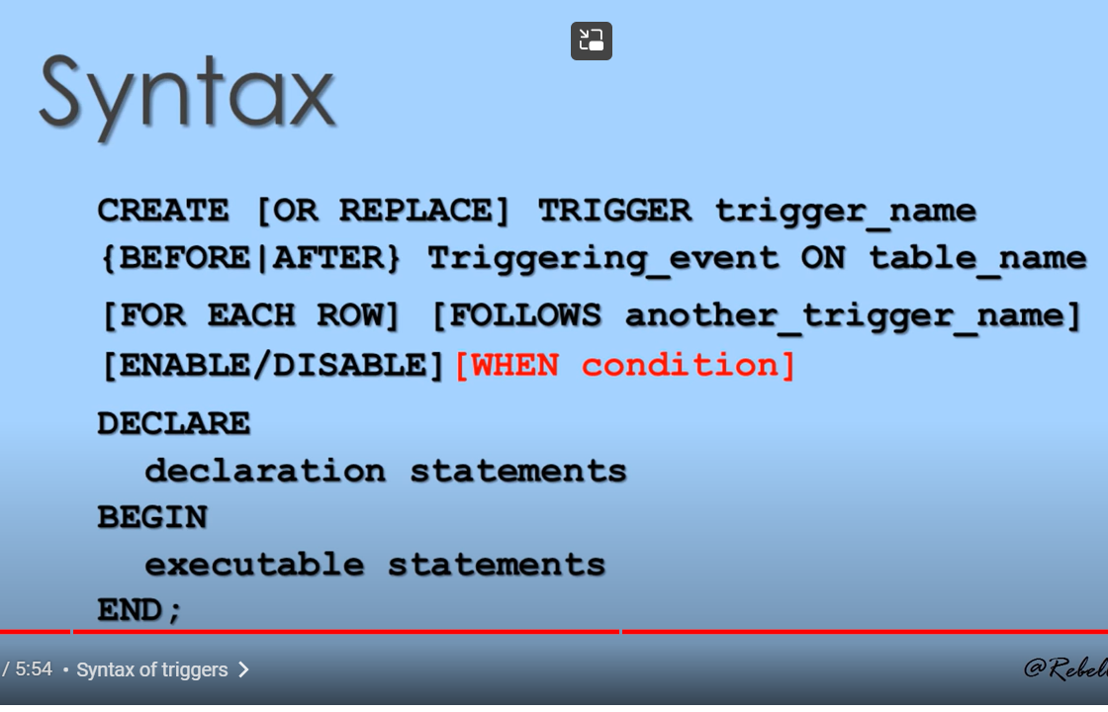

Follows another trigger is optional(we use when we have more number of triggers

Use enable- to make trigger effective

Use- disable- to make trigger non effective

# DML Trigger With Before Insert, Update and Delete DML

## **Data Manipulation Language (DML) Triggers.**

As the name suggests these are the triggers which execute on DML events or say depend on DML statements such as Update, Insert or Delete. Using DML trigger you can control the behavior of your DML statements.

Since the theory has already been discussed in the previous tutorial hence I won’t bore you further. You can refer to the previous tutorial “Introduction to Triggers” anytime.

# DML Trigger With Before Insert, Update and Delete DML

Created table

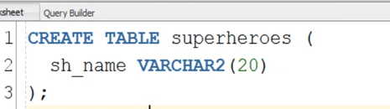

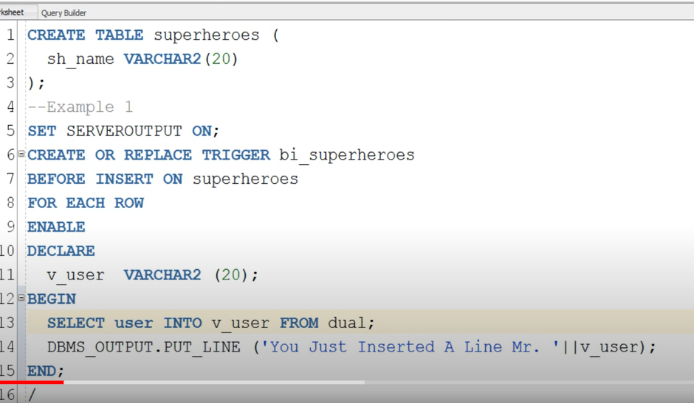

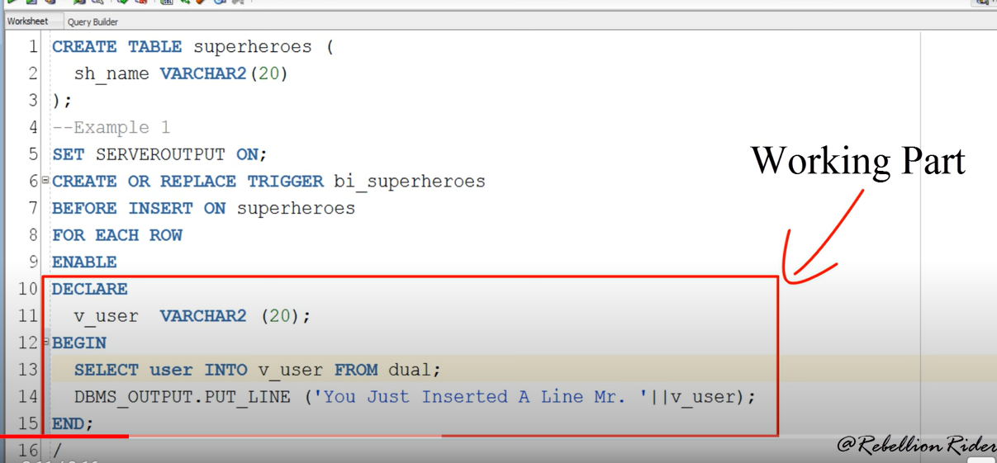

Above one defining part

Below is working part of trigger

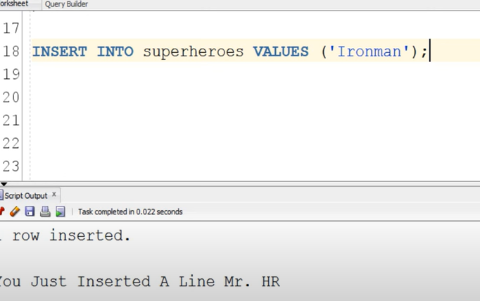

We can also create trigger for UPDATE

Trigger : special stored procedure

Execute automatically when any event occurs

Events – delete, insert , update

While doing any event occurs- when it get conflict- instead of triggers execute

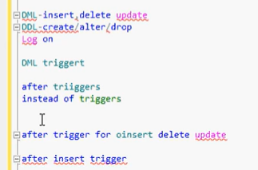

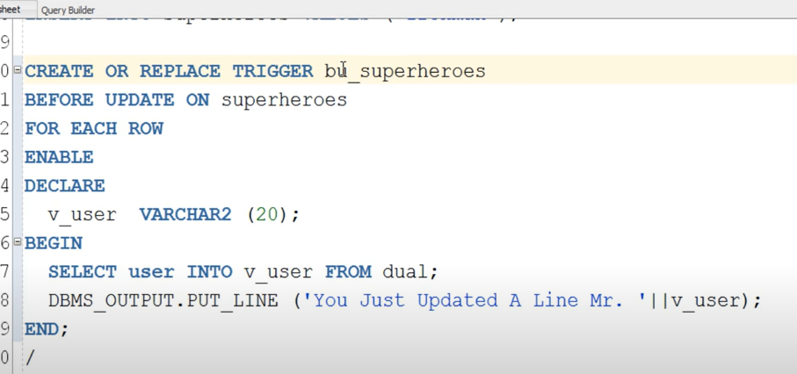

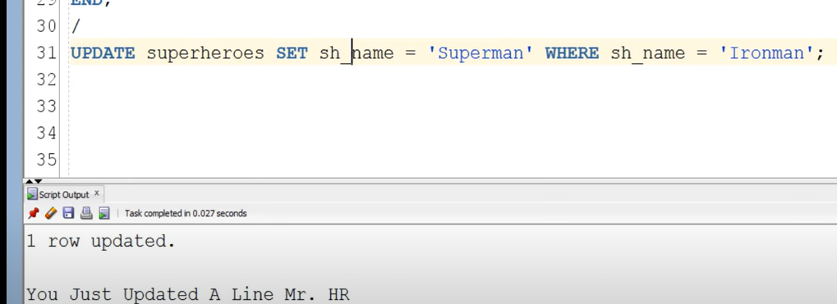

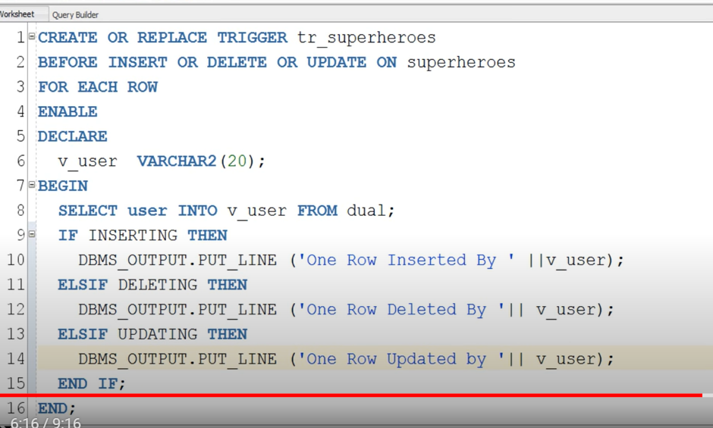

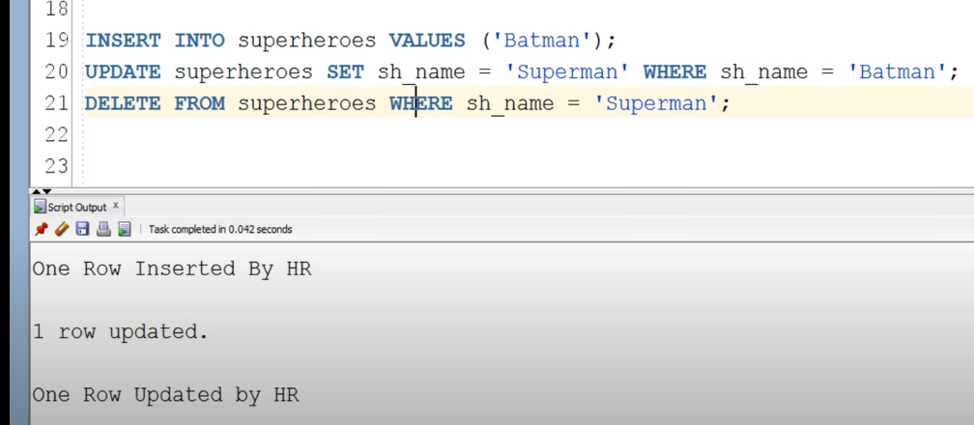

We have created a table to note all triggering events



Now created trigger on table employee_details for insert

Whenever trigger happens – trigger event added to employeeaudit table

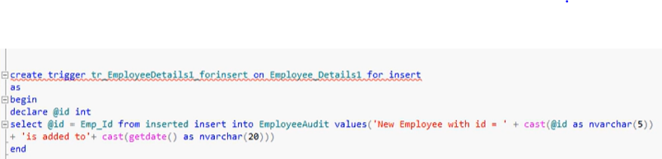

Inserted is temp table, when we insert record first it adds into temp inserted table

Now when we insert a record

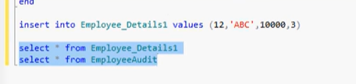

Added trigger to table

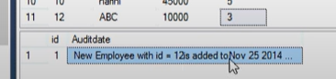

# DML after trigger for Delete statement

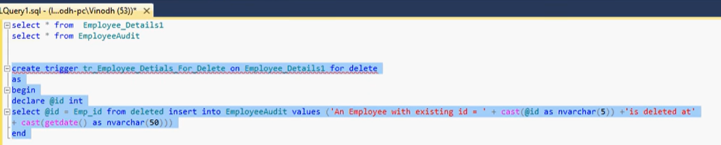

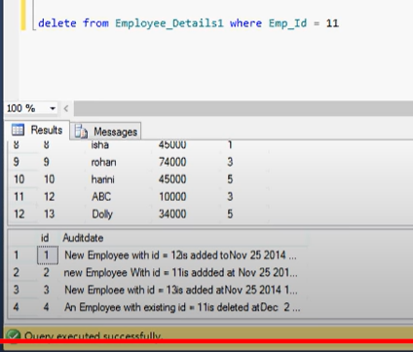

# DML After Trigger for Update Statement

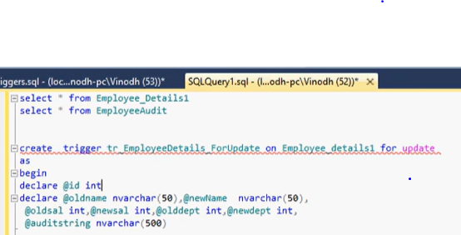

Since id wont change

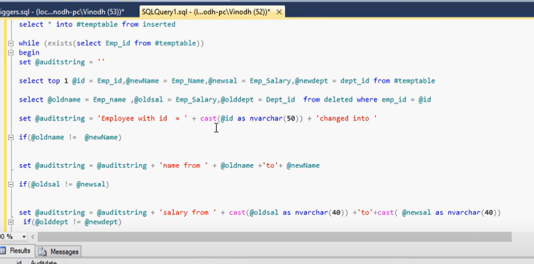

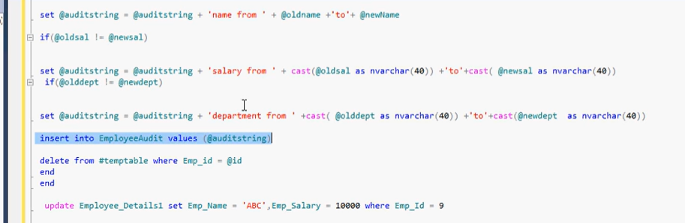

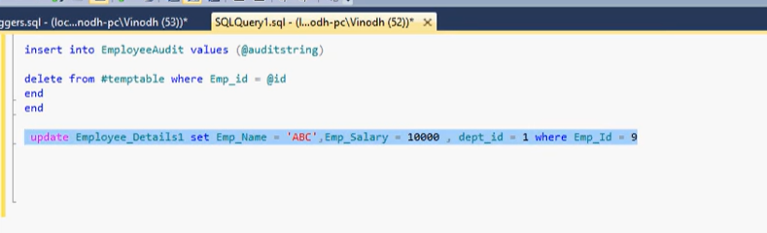

Instead of trigger:

It happen against a event(instead of event, event ki badulu)

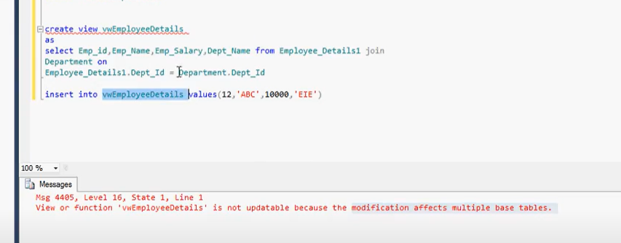

When we are trying insert a record it throw error as view depends on multiple table

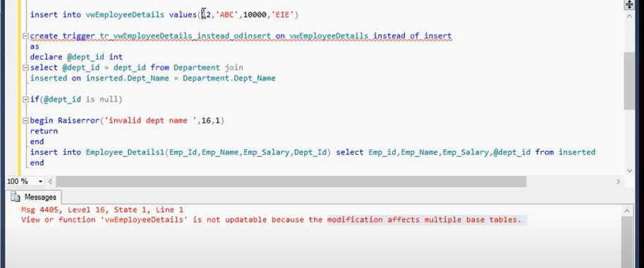

# DML instead of trigger for update statement

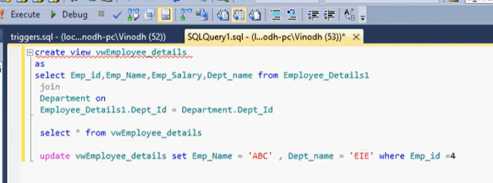

Error since it came from multiple tables

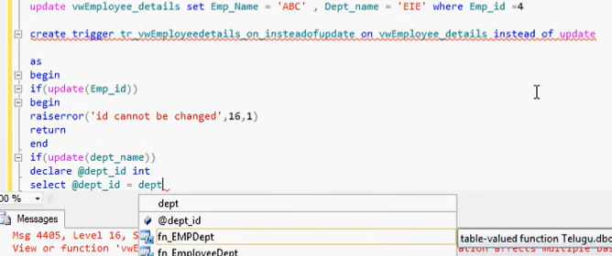

Id – we cant update – raise error

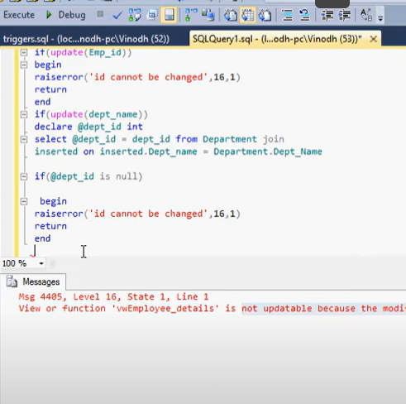

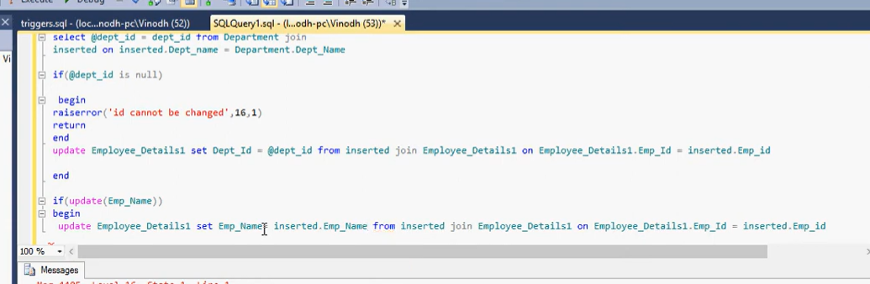

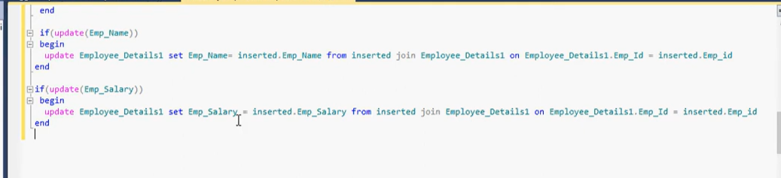

# DML instead of delete trigger for delete statement

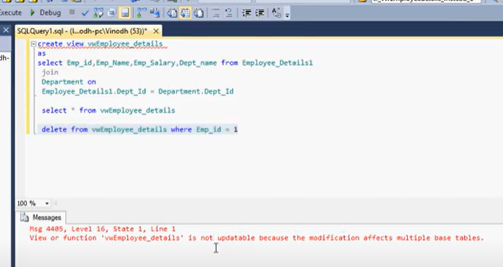

Gave error as it came from multiple tables

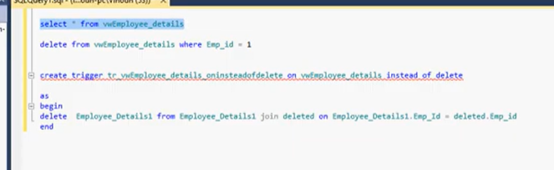

# DDL Triggers and disabling triggers)

Drop, alter, create- DDL commands

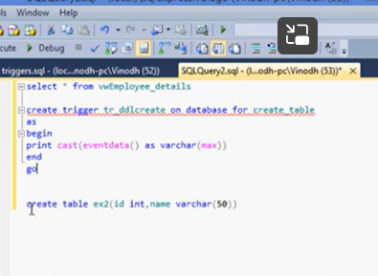

# Table Auditing using DML Triggers in Oracle PL/SQL

To keep on eye on user who is updating, deleting data

## **Table Auditing**

Table auditing means keeping a **track of all the dml activities performed on a specific table of the database** for example which user **Inserted, updated or deleted a row from the table** and when. It is like **spying on the users** who are messing your table’s data.

### **Example**

For the demonstration we will use the table ‘Superheroes’ which we created in the previous tutorial.

Suppose you want to keep an eye on the users **who are inserting, updating or deleting data from the ‘Superheroes’ table**. Let’s see how we can achieve this. To do so we will need another table in which we can journal the auditing data entries.

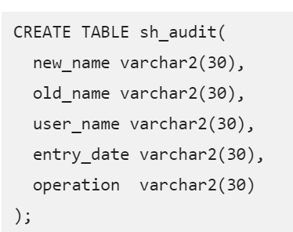

This table **sh_audit has 5 columns** which will store the auditing information such as the new data inserted or updated, old data which is updated or deleted from the table, name of the user who did it along with the date and time, also the type of DML operation performed.

Next we will write a trigger on the source table superheroes and will store the data into the auditing table sh_audit.

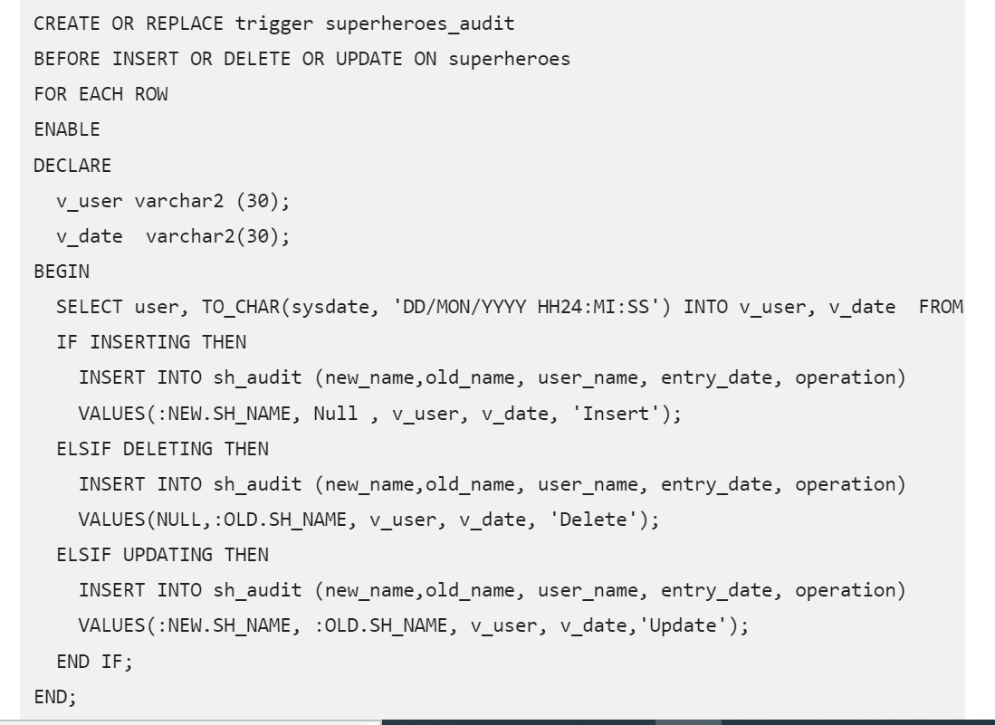

## **Pseudo Records (New/Old)**

If you will carefully see the **Insert statements used in the IF-THEN-ELSIF statements** in the above code, we used some **Pseudo Records such as ‘:New’** **or ‘:Old’** followed by the **name of the column of our source table sh_name.**

**These Psuedo Records helps us in fetching data from the sh_name column of the underlying source table ‘Superheroes’ and storing it into the audit table sh_audit.**

Pseudo **Record ‘: NEW’, allows you to access a row currently being processed**.

In other words, **when a row is being inserted or updated into the superheroes** table. Whereas Pseudo Record **‘: OLD’ allows you to access a row which is already being either Updated or Deleted from the superheroes table.**

In order to fetch the data from the source table, you have to first write the proper **Pseudo Record (New/Old) followed by dot (.) and the name of the column of the source table whose value you want to fetch.**

For example in our case we want to fetch the data from sh_name column which belongs to our source table superheroes. Thus we will write **“: New. sh_name”** for fetching the current value and to fetch the previously stored value we will write “: OLD. sh_name”. Once the values are fetched the INSERT dml will store these values into the respective columns of the audit table.

## **Restriction on Pseudo Record**

* For an **INSERT trigger, OLD contain no values, and NEW contain the new values.**
* For an UPDATE trigger, OLD contain the old values, and NEW contain the new values.
* For a DELETE trigger, OLD contain the old values, and NEW contain no values.

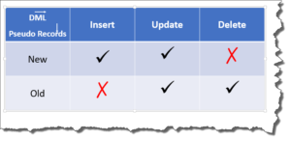

Once you execute and compile this trigger then you can take it on a test run by writing DML statements on the underlying source table ‘Superheroes’. For example you can try Inserting a row in superheroes table and then check the audit table whether there is some data or not.

INSERT INTO superheroes VALUES ('Superman');

Similarly you can write Update and Delete DML statements on Superheroes table.

UPDATE SUPERHEROES SET SH_NAME = 'Ironman' WHERE SH_NAME='Superman';

Or

DELETE FROM superheroes WHERE SH_NAME = 'Ironman';

As soon as you execute any of these DML statements on the underlying table superheroes, the trigger will execute in the background and insert the audit data into the audit table sh_audit.

That is it for today’s tutorial hope you enjoyed reading and learnt something. Please share this post on your social media with your friends and help them in learning something new and stay tuned as in the next tutorial we are going to see some other cool tricks of triggers.

# Make synchronized backup copy of a table using DML Trigger

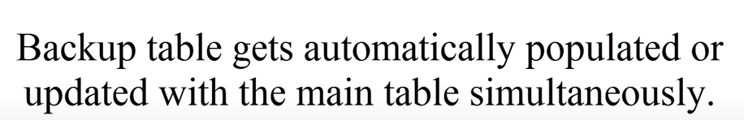

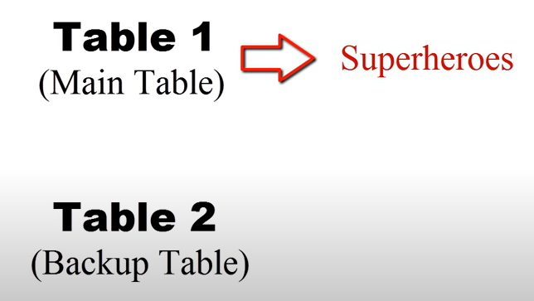

Created back up table



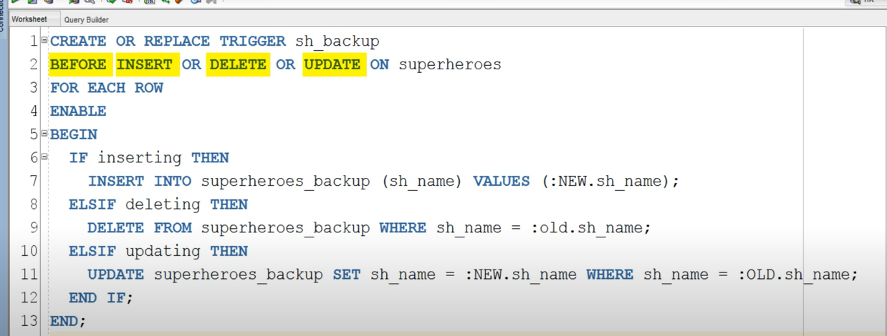

# DDL Trigger with Schema Auditing Example



When schema changes and by whom

Created audit tabl to record triggers

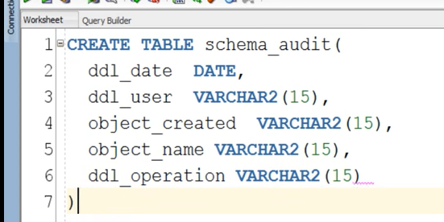

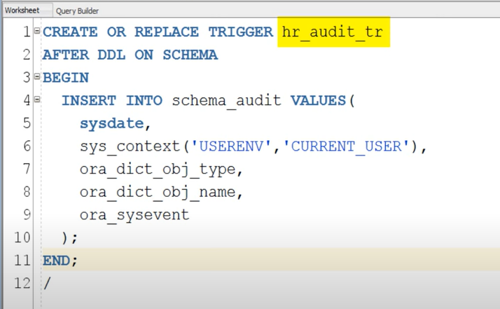

 usually takes 3 parameters

2 are mandatory

1st one : oracle build namespace

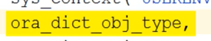

Ex: creating table

Table is object name

Type of object on which “ddl” operation occurred

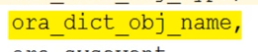name of object”

Ex table name iven by user

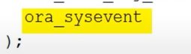 which ddl operation was executed

Ex: create, truncate

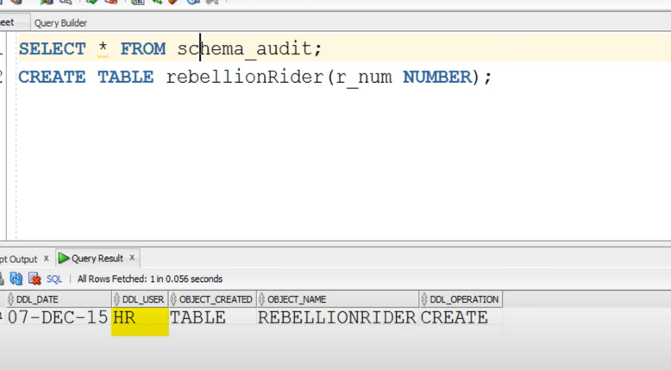

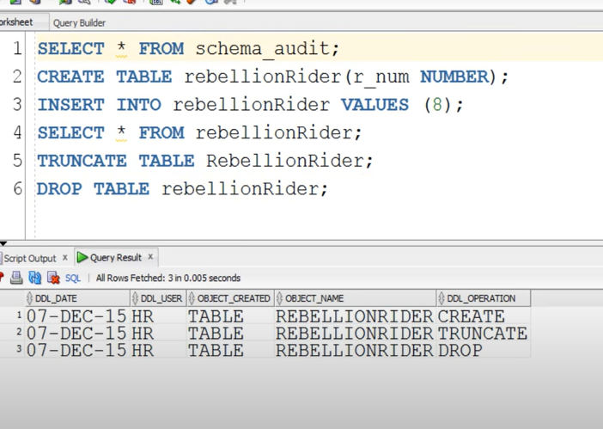

Its only works on particular schema which we have created

Not for entire database

## **DDL Trigger for Database Auditing.**

Similar to the schema auditing with some minor changes in the above trigger you can audit **your database** too. But for that first **you need to logon to the database using either SYS user or SYSTEM user.**

**Suggested reading:**[***How to connect to the database using SYS user.***](http://www.rebellionrider.com/how-to-make-new-database-connection-in-sql-developer-rebellionrider/)

After doing that you have to **create the above shown table under the same user** so that your trigger can dump the auditing data without any read and write errors.

CREATE OR REPLACE TRIGGER db_audit_tr

AFTER DDL ON DATABASE

BEGIN

INSERT INTO schema_audit VALUES (

sysdate,

sys_context('USERENV','CURRENT_USER'),

ora_dict_obj_type,

ora_dict_obj_name,

ora_sysevent);

END;

/

If you notice the **second line of this code** carefully then you will find that we have **replaced** the **keyword** **Schema** with the **keyword** **Database** which indicates that this trigger will work for the whole database and will perform the underlying work.

To **create a trigger on database** we require **ADMINISTER** **DATABASE** **TRIGGER** system privilege. All the **administrative users such as sys or system already has these privileges** by default that is the reason we created this database auditing DDL trigger using these users. Though you can create the same trigger with any user by granting the same privileges to them but that is not advisable because of your database security reasons.

# How To Create Database Event 'LogOn' Trigger In Oracle

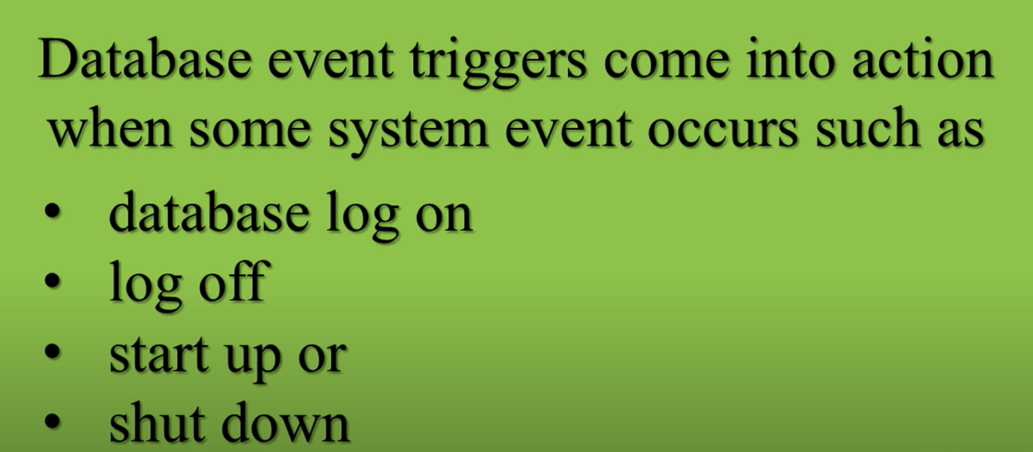

Database event triggers also known as **system event triggers** come into action when **some system event occurs** such as database **log on, log off, start up or shut down**. These types of triggers are majorly used for **monitoring activity of the system events** and have been proved quite a powerful tool for a DBA.

## **Types of Database Event Triggers.**

1. Schema Level Event Triggers
2. Database Level Event Triggers

Schema level event triggers can work on **some specific schemas** while the **database event triggers have database wide scope**. In other words database event triggers can be created to monitor the system event **activities of either a specific user/schema or the whole database.**

### **Object/System Privileges**

**Schema level event triggers** can be created by **any user of your database** who has **CREATE TRIGGER system privilege** while the database event trigger **can only be created by privileged user such as SYS or SYSTEM who has ‘Administrative Database Trigger’** System Privileges.

**Suggested Reading:**[**Introduction To Privileges In Oracle Database [Interview Edition]**](http://www.rebellionrider.com/user-privileges-in-oracle-database/)

## **Syntax**

CREATE OR REPLACE TRIGGER trigger_name

BEFORE | AFTER database_event ON database/schema

BEGIN

PL/SQL Code

END;

/

Please watch the video tutorial for detailed explanation of the syntax.

### **Example. Schema Level Event Trigger.**

Suppose user HR is a control freak and wants to monitor its every log on and log off activity. In this case what HR can do is, create event triggers on Log on and log off database event in its own schema.

#### **Step 1: Connect to the database**

Connect to the database using the user/schema in which you want to create the trigger. For the demonstration I will connect using my HR user.

C:/> Conn hr/hr

Or if you are using SQL Developer then read [here](http://www.rebellionrider.com/how-to-make-new-database-connection-in-sql-developer-rebellionrider/) on how to connect to the database using the same.

#### **Step 2: Create a Table**

Next you will need a table to store the logon and logoff data.

CREATE TABLE hr_evnt_audit

(

event_type VARCHAR2(30),

logon_date DATE,

logon_time VARCHAR2(15),

logof_date DATE,

logof_time VARCHAR2(15)

);

#### **Step3: Write the trigger Logon Schema Event Trigger.**

Now you are connected to the database using the desired user and also have the table ready to store the data. The only thing which is left is the trigger.

This trigger will fire every time HR user logs on to the database and respective values will be stored into the table which we just created in the step 2.

CREATE OR REPLACE TRIGGER hr_lgon_audit

AFTER LOGON ON SCHEMA

BEGIN

INSERT INTO hr_evnt_audit VALUES(

ora_sysevent,

sysdate,

TO_CHAR(sysdate, 'hh24:mi:ss'),

NULL,

NULL

);

COMMIT;

END;

/

That is how we create a LogOn event trigger in Oracle Database. You can watch the video tutorial on my YouTube channel on the same topic where I created and tested the trigger live. And Stay tuned as in the next tutorial we will see how to create a logoff event trigger in Oracle Database.

Please Share this blog on your Facebook, Twitter and by any means you find convenient with the hashtag #RebellionRider or you can also tag me for the immediate shoutout on my wall.

That’s it guys. Hope you enjoyed reading. Thanks & have a great day!

# Instead-Of Insert Trigger in Oracle Database

Only on views

Not on tables

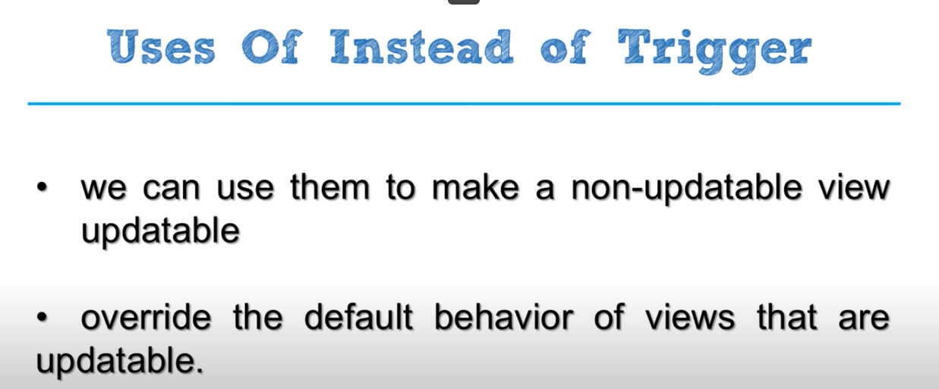

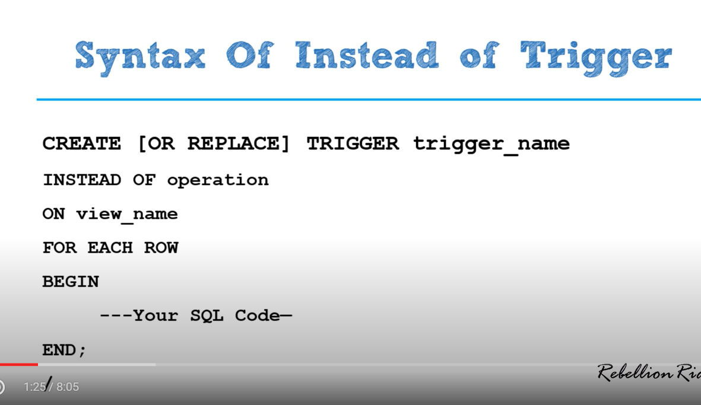

So far we have **learnt DML, DDL and System Event Triggers** in Oracle Database.

## **instead Of Trigger**

Instead-of triggers in oracle database provide a **way of modifying views** that **cannot be modified directly through the DML statements**. By using Instead-of triggers, you can perform **Insert, Update, Delete and Merge operations on a view in oracle database.**

## **Restriction on Instead-of View.**

Instead-of triggers can control Insert, Delete, Update and Merge operations of the **View**, **not the table**. Yes you heard it right, you can write an instead-of trigger on Views only and not on tables in Oracle database.

**Uses of Instead-of trigger.**

Since an Instead-of trigger can only be used with views therefore we can use them to make a **non-updatable view updatable** as well as to override the default behavior of views that are updatable.

## **What are Modifiable and Non Modifiable Views?**

A view is **naturally** **modifiable** if you **do not require INSTEAD OF triggers to insert, delete or update data** as well as if it complies to the restrictions discussed herewith. **If the view query comprises of any of the mentioned constructs, then it is not naturally modifiable** and therefore you cannot perform inserts, updates, or deletes on the view:

* Set operators
* Aggregate functions
* GROUP BY, CONNECT BY, or START WITH clauses
* The DISTINCT operator
* Joins (however, some join views are updatable)

In case **a view consists of pseudo columns or expressions**, then **it is only possible to update it with an UPDATE statement** and that also when it does not refer to any such pseudo columns or for that matter, expressions.

## **Syntax of Instead-Of Trigger**

CREATE [OR REPLACE] TRIGGER trigger_name

INSTEAD OF operation

ON view_name

FOR EACH ROW

BEGIN

---Your SQL Code—

END;

/

For line-by-line detailed explanation of the above syntax please refer my video tutorial. There I have explained all the clause and keyword of the syntax in detail.

### **So you asked…**

When does an Instead-of trigger fires – Before or After the triggering event?

If you noticed carefully then you’ll see that **we do not have either BEFORE or AFTER clause in the syntax**. This is because unlike other triggers, **instead-of trigger executes neither BEFORE nor AFTER but instead of a triggering event.** That is why we do not need to specify either BEFORE or AFTER clause.

## **Examples**

Instead-of Insert Trigger

Instead-of trigger can be best demonstrated using a View joining two or more tables. Thus in this example I will create two simple tables and will then create a view over them. After that I will create an Instead of trigger for Insert operation on this view.

### **Step1: Create Tables**

Table 1- trainer

CREATE TABLE trainer

(

full_name VARCHAR2(20)

);

Table 2- Subject

CREATE TABLE subject

(

subject_name VARCHAR2(15)

);

Insert dummy data into the above tables

INSERT INTO trainer VALUES ('Manish Sharma');

INSERT INTO subject VALUES ('Oracle');

### **Step 2: Create View**

In this step I will create a view which will show you the combined result of the data from the two tables above.

**Suggested Reading:**[**How To Create SQL View in Oracle Database**](http://www.rebellionrider.com/what-is-sql-view-in-oracle-database/)

CREATE VIEW vw_rebellionrider AS

SELECT full_name, subject_name FROM trainer, subject;

This is a non-updatable view which you can confirm by executing any DML statement over it. Error as a result of DML operation on this view will be your confirmation.

### **Step 3: Create Trigger**

Next I will create an Instead-of Insert trigger over the view vw_rebellionrider that we created in step 2.

CREATE OR REPLACE TRIGGER tr_Io_Insert

INSTEAD OF INSERT ON vw_rebellionrider

FOR EACH ROW

BEGIN

INSERT INTO trainer (full_name) VALUES (:new.full_name);

INSERT INTO subject (subject_name) VALUES (:new.subject_name);

END

On successful execution, this **trigger will insert a new row of data into both the underlying tables of the view vw_rebellionrider**. You can confirm that by executing an insert DML over the view.

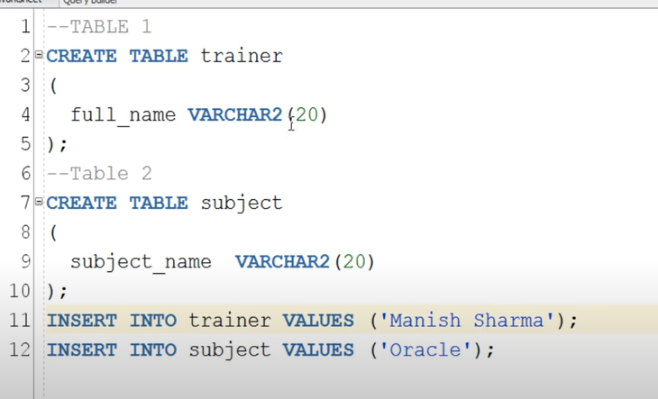

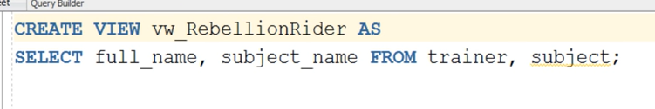this view is not updatable

Using instead of trigger we can make non updatable view to an updatable view

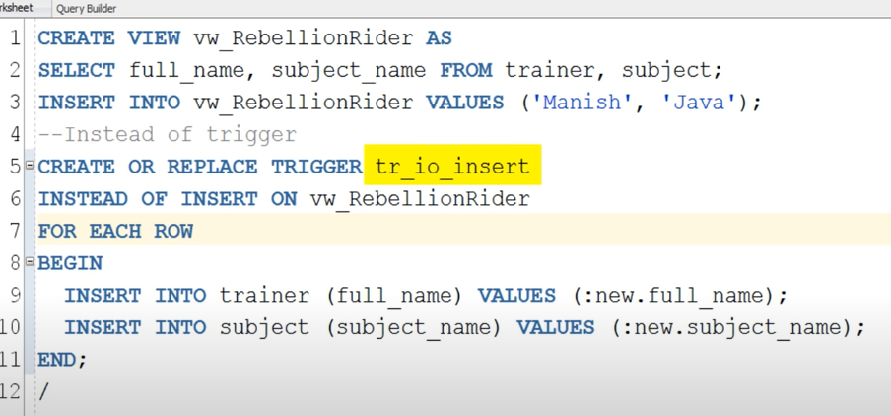

# How To Create an Instead-of Update Trigger

## **Instead-Of Update Trigger**

**Instead-of update trigger** will override the default behavior of your update operation when you execute the update statement and will let you update the data of the underlying tables over which your view is created.

### **Example:**

Tables (Trainer and Subject) and View (VW_RebellionRider) used in this example are the same as the ones we created in the previous tutorial.

CREATE OR REPLACE TRIGGER io_update

INSTEAD OF UPDATE ON vw_rebellionrider

FOR EACH ROW

BEGIN

UPDATE trainer SET FULL_NAME = :new.full_name

WHERE FULL_NAME = :old.full_name;

UPDATE subject SET subject_NAME = :new.subject_name

WHERE subject_NAME = :old.subject_name;

END;

/

On successful execution this trigger will let you execute an Update DML on the view.

Hope you enjoyed reading. Help others in learning the concepts by sharing this blog on your Social media. Thanks and have a great day!

### **Instead-of Delete trigger Example.**

In this example I will again use the View VW_RebellionRider which we created earlier and have consistently used in this Instead-of trigger series so far.

Needless to say that **executing DELETE DML on this view will return an error** because of its non-updatable nature. Thus the only way to perform DELETE DML on this view is by using an Instead of trigger. Let’s quickly create one.

CREATE OR REPLACE TRIGGER io_delete

INSTEAD OF DELETE ON vw_RebellionRider

FOR EACH ROW

BEGIN

DELETE FROM trainer WHERE FULL_NAME = :old.FULL_NAME;

DELETE FROM subject WHERE SUBJECT_NAME= :old.SUBJECT_NAME;

END;

/

On successful execution this trigger will allow you to execute DELETE DML on the view.

This is a very simple example of Instead-of delete trigger intended to teach you the proper way of creating an Instead-of Delete trigger. Hope you enjoyed this quick blog.

Also go ahead and watch to participate in the giveaway on my YouTube channel. Thanks & have a great day!